
RoboFace
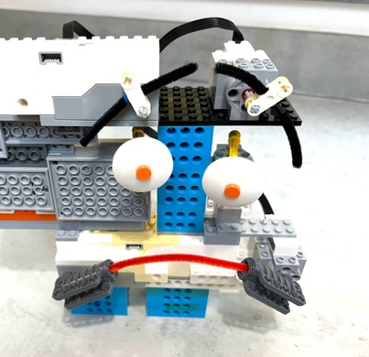
Register/login at https://scratch.mit.edu
Build a robot with an expressive face. Using the Lego Boost you can build mouth, eyes, or eyebrows. Team up with others to build a whole face.
- Create a new project, add the LEGO BOOST extension, and connect the BOOST.
Each part of the face needs two motors. Use one of the motors on the Boost control brick and the extra motor.
- Start by building your Lego. You can use “pipe cleaners” to create the mouth and eyebrows.
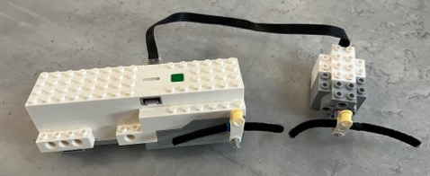
Here are some ideas…
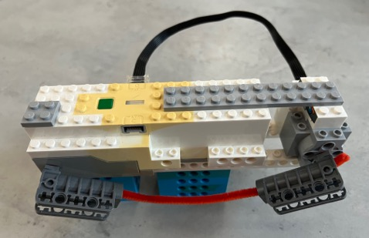
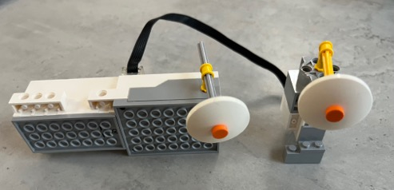
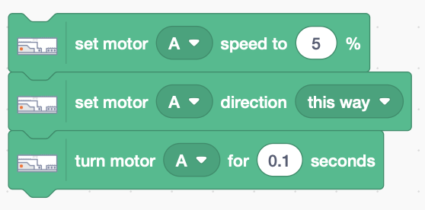
- Choose a motor and add code that sets motor speed to very slow (5%) in any direction. Turn the motor for a short time to see which way it moves.
- Choose your other motor and duplicate the above code to make it move. Change the motor identifier as needed.
- This code makes a small step, so it inside a repeat loop turning both motors to change expression.
- Copy the code to make another block that moves both motors in the opposite direction.
- Trigger each code block using different letters. For example, ‘h’ for happy, ‘s’ for sad, or ‘l’ and ‘r’ to swivel the eyes left and right.
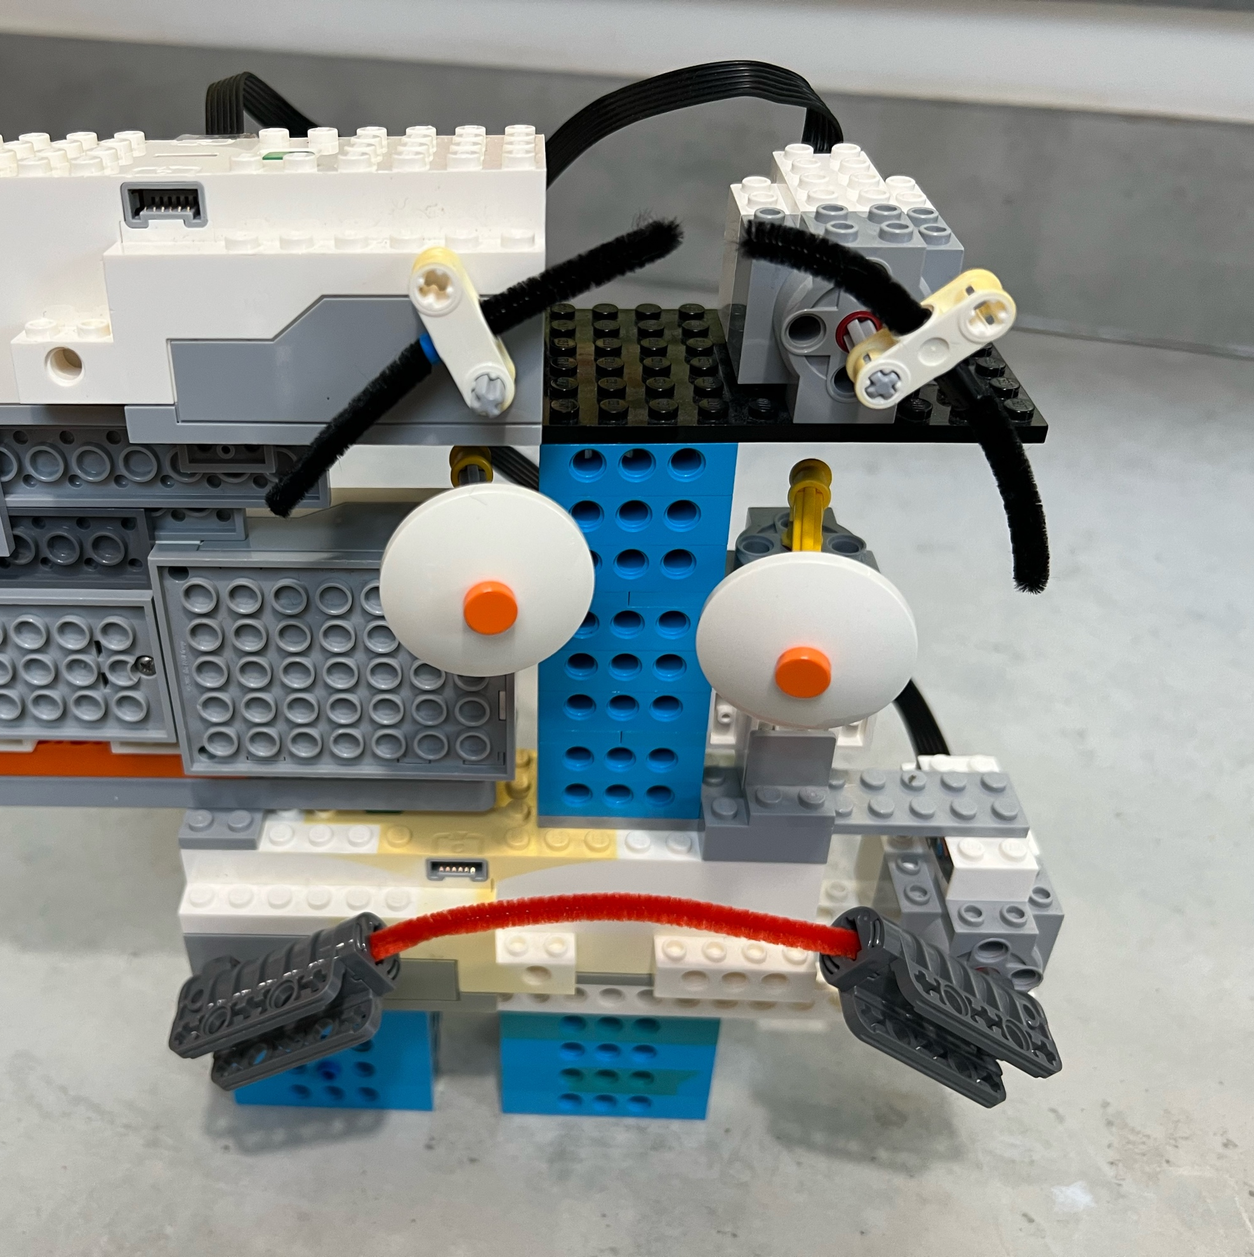
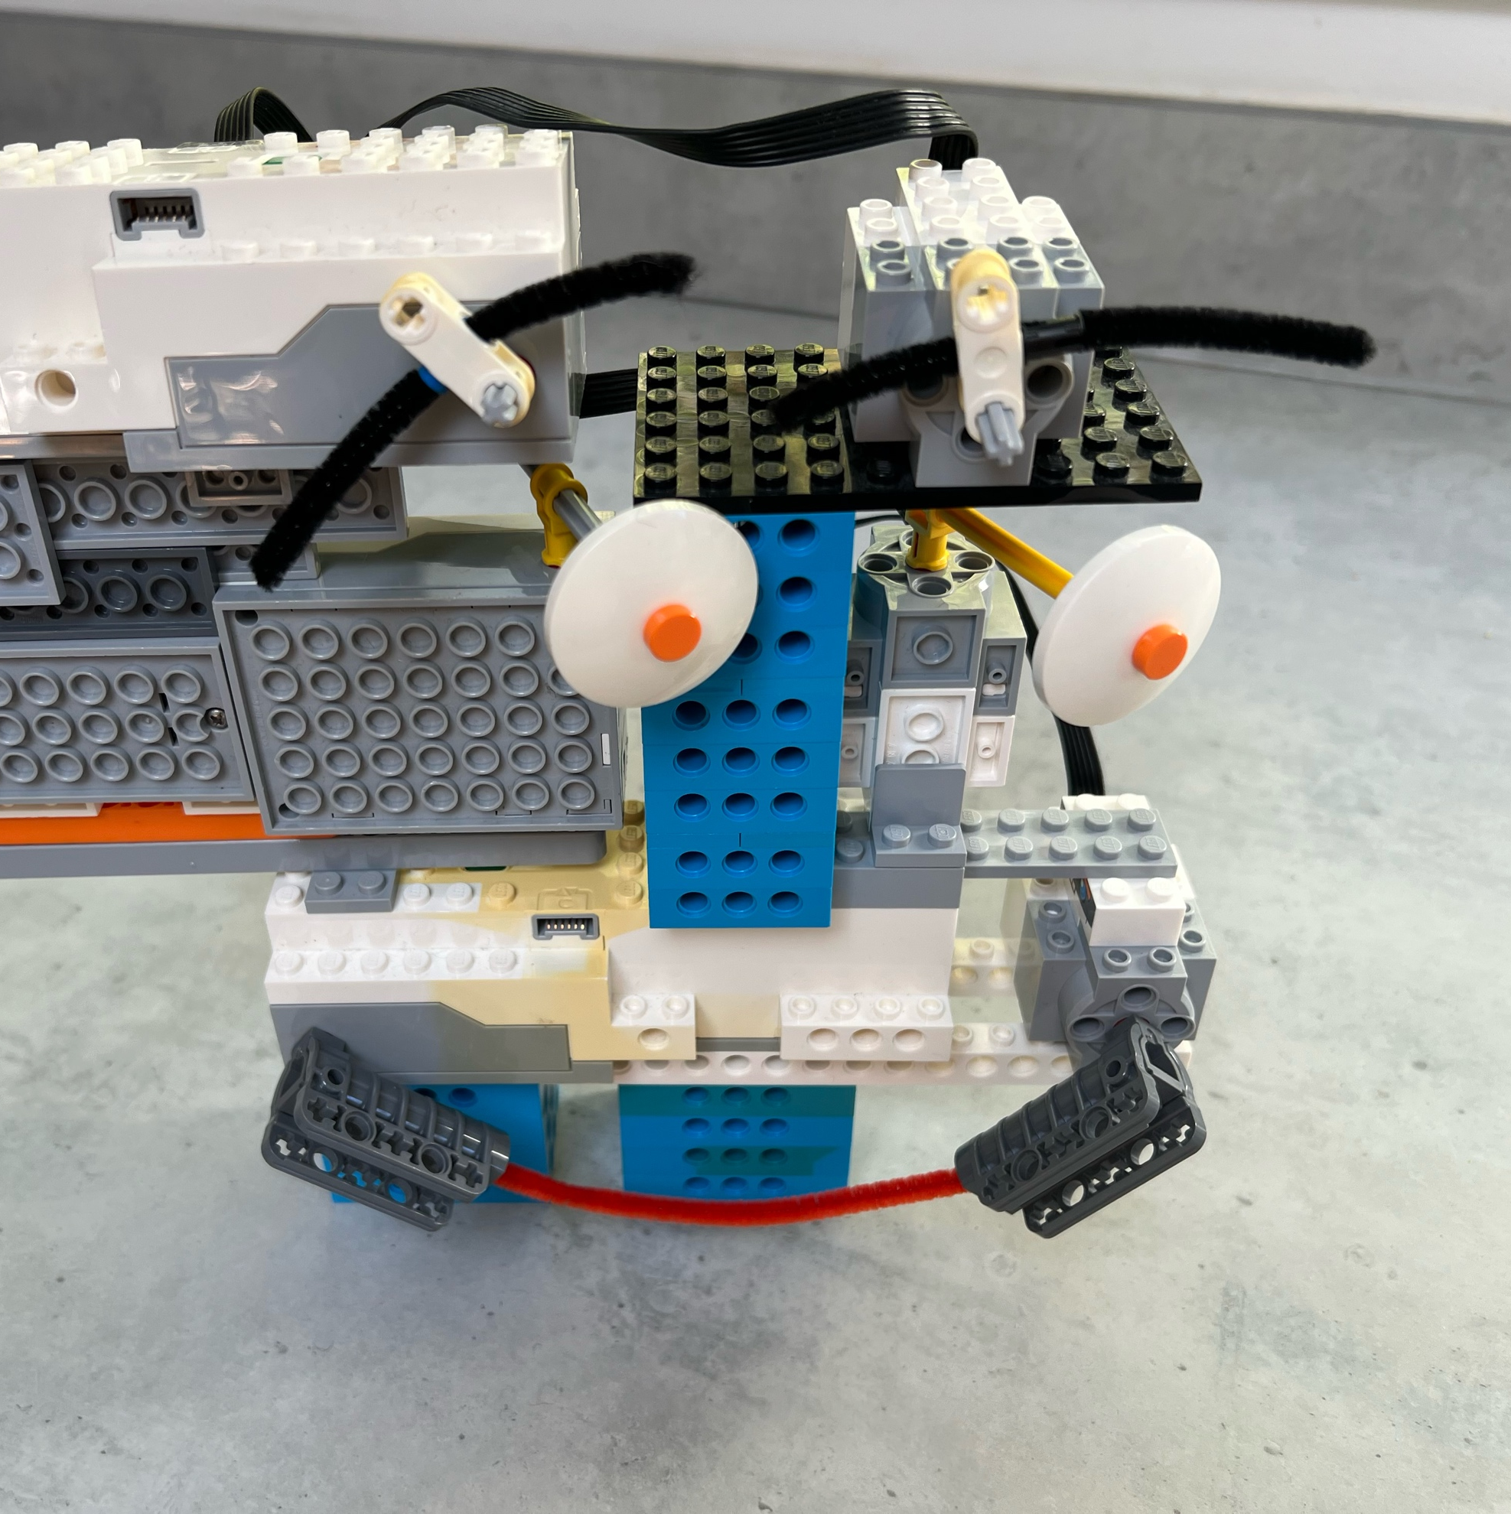
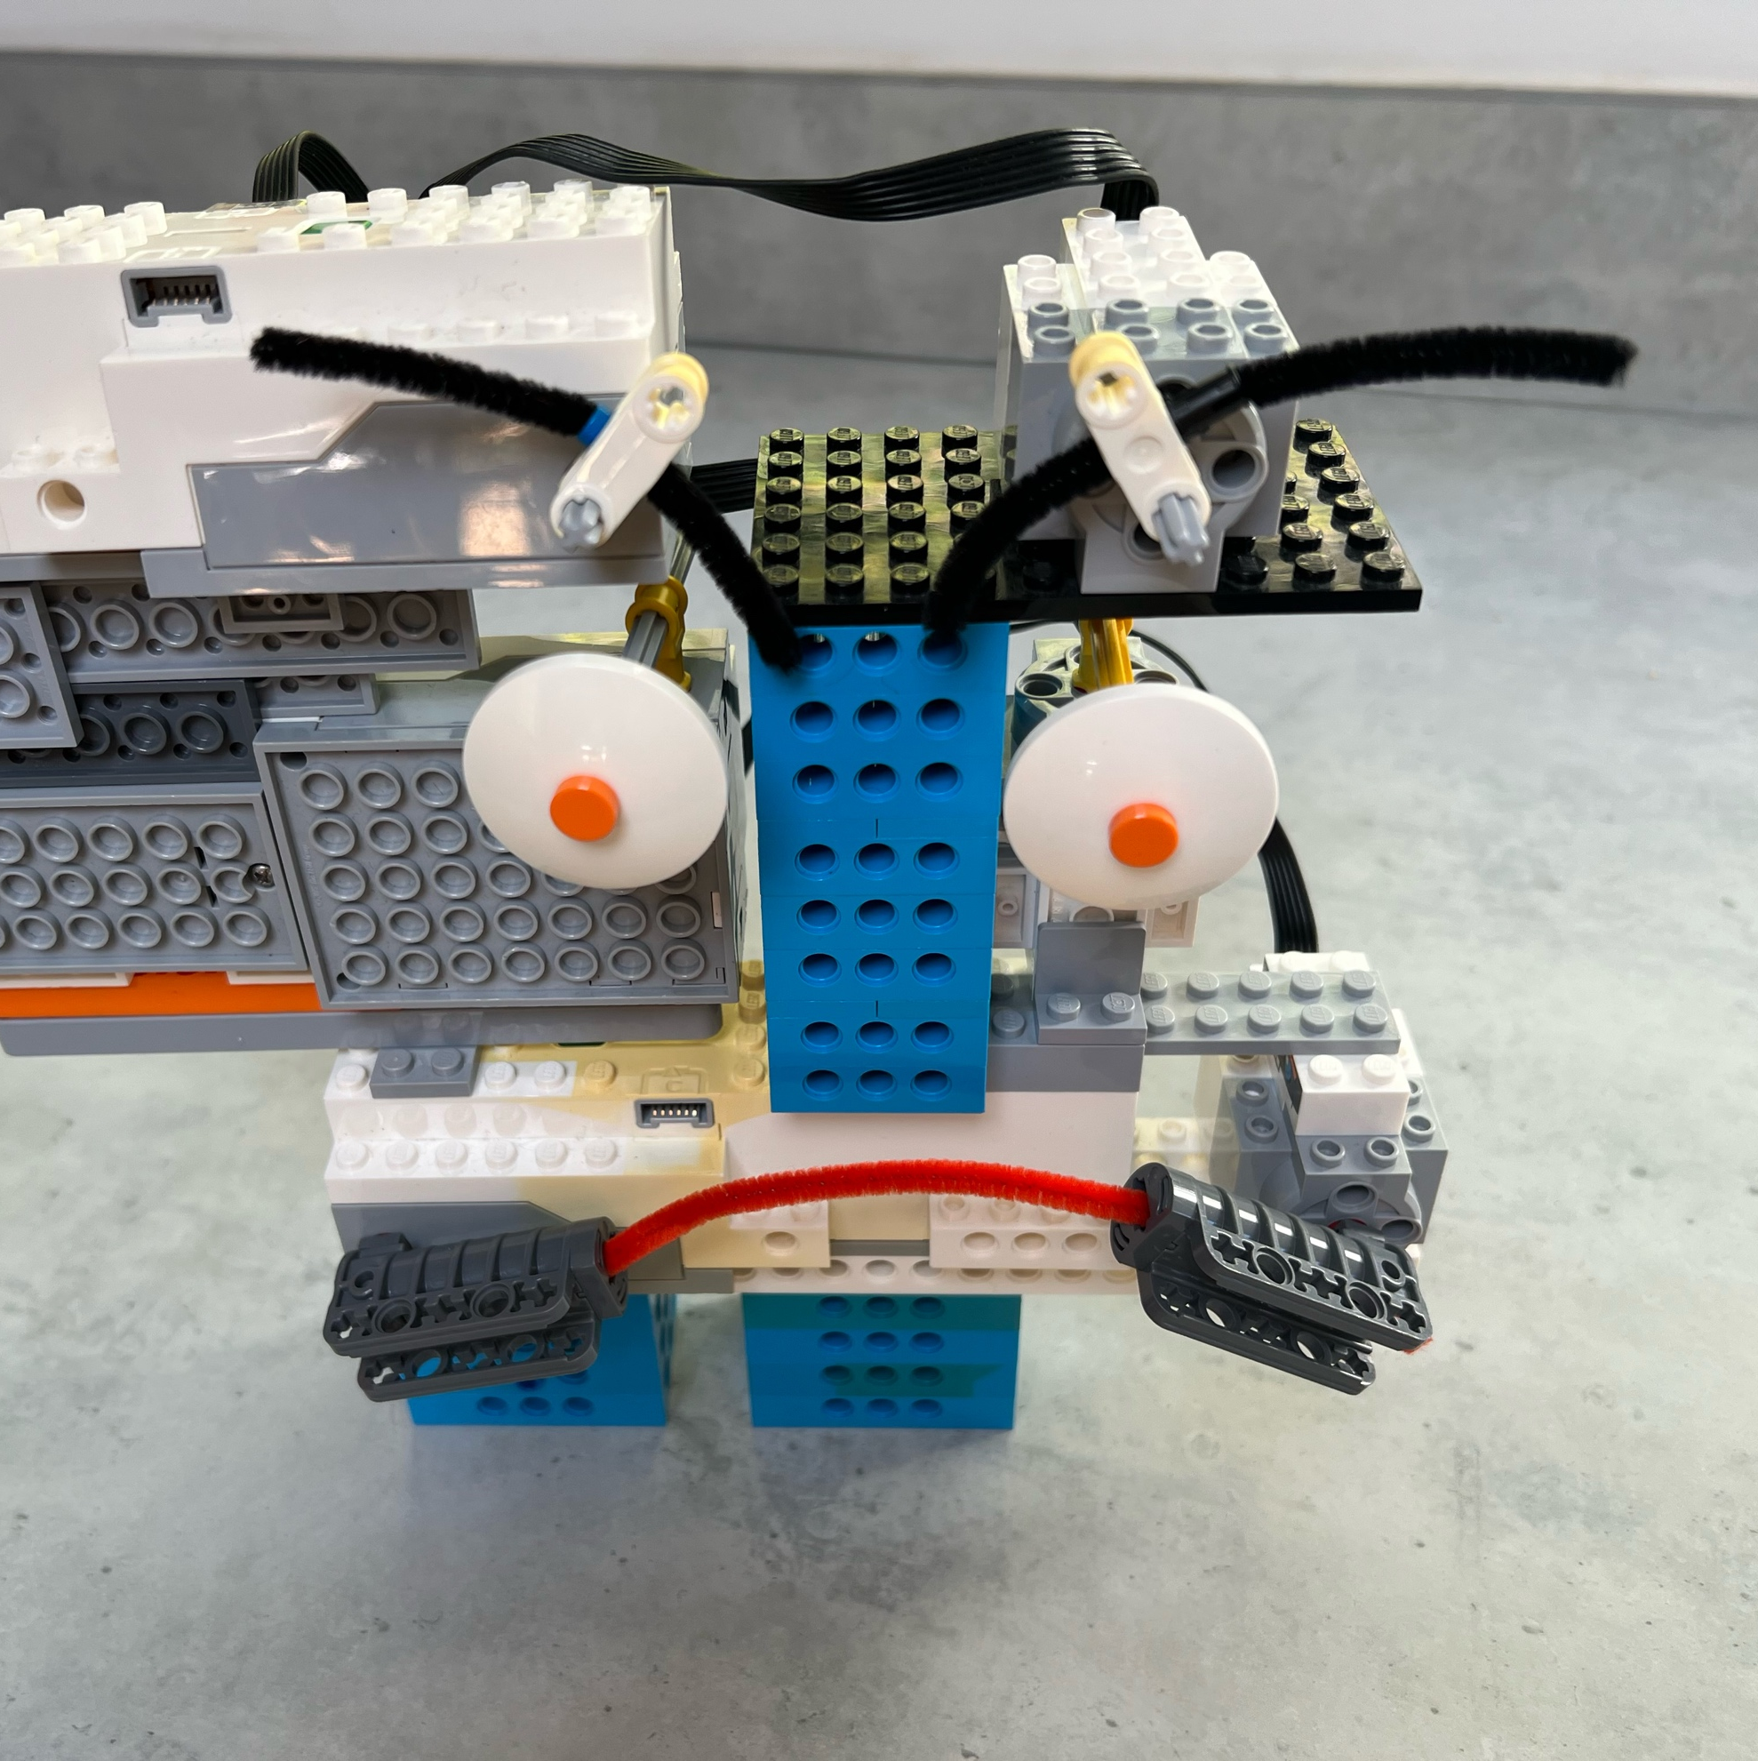
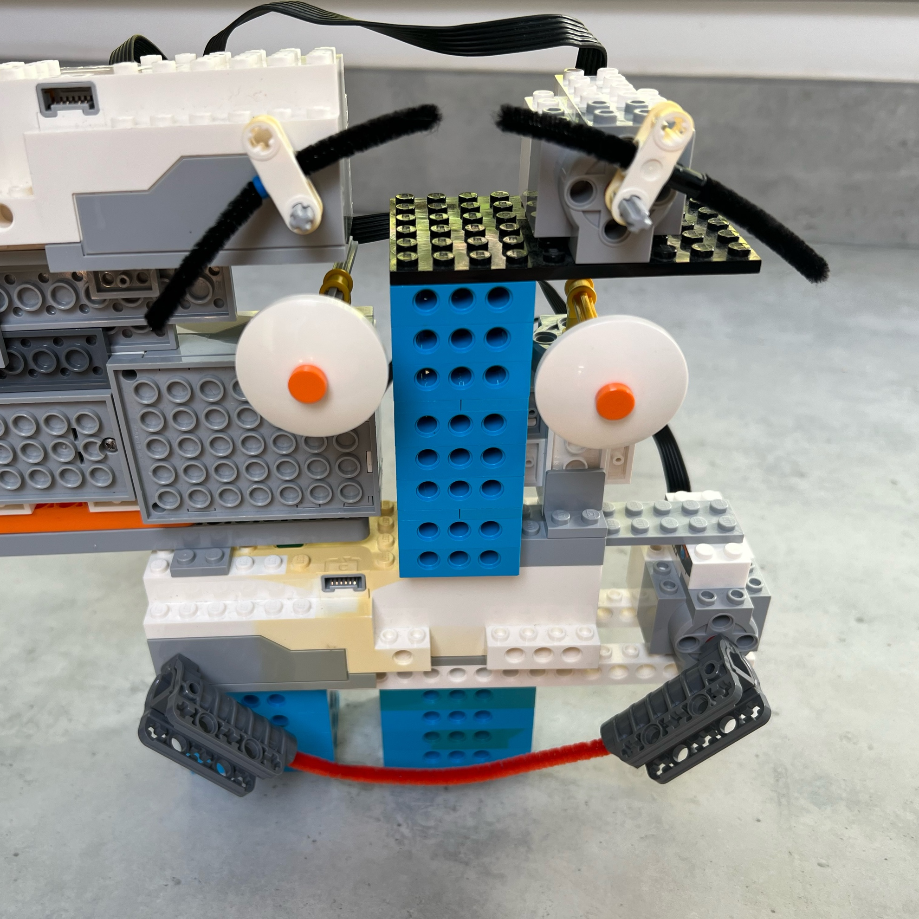
- Now assemble the whole face. The tricky thing is that the Lego must be added at different orientations.

Save your code with a good name. File > Save now

