
Booster Car

Register/login at https://scratch.mit.edu
A remote-controlled car that can go forward and in reverse.
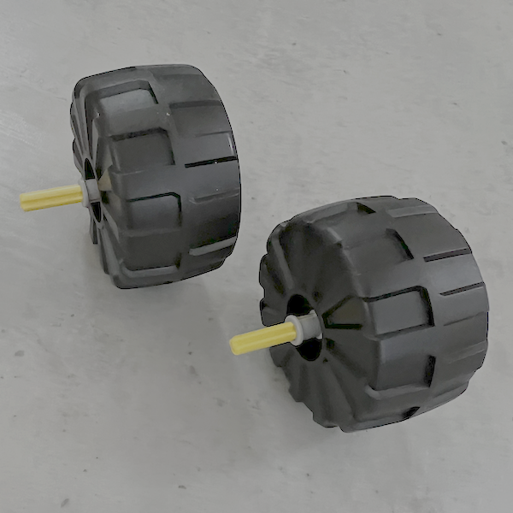
- Create a new Scratch project, add the LEGO BOOST extension, and connect the BOOST.
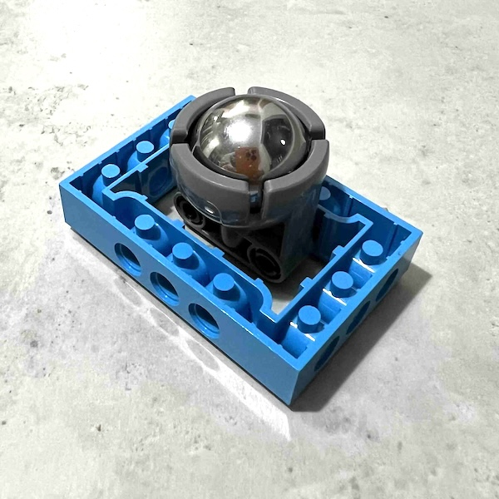
- Find and build two wheels with a cross-shaped axle to fit into motors A and B on front of the BOOST.
- You need a wheel at the back. The image (left) shows one design idea, using a caster wheel.
- Add all the wheels to the BOOST.
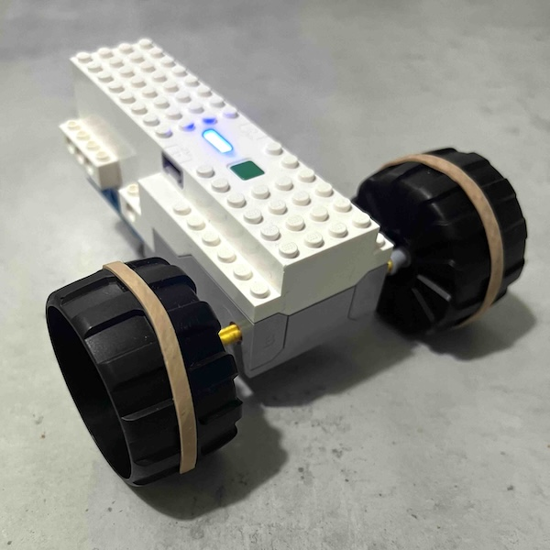
- Decorate your car with your own Lego designs so it doesn’t get mixed up with somebody else’s car.

Now write code to control the car from Scratch. Use the arrow keys to drive it.
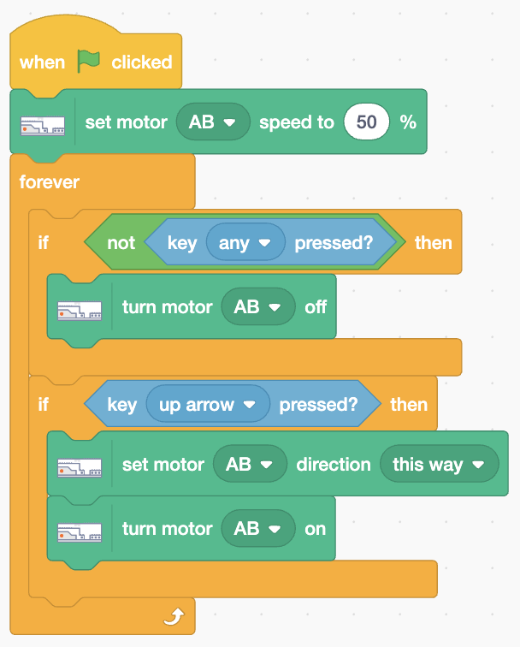
- Add code (right) that sets the motor speed then in a forever loop detects if no key is pressed and turns both motors off.
The code responds to the up arrow by setting the motor direction to forwards, “this way”, before turning both motors on.
Add steering.
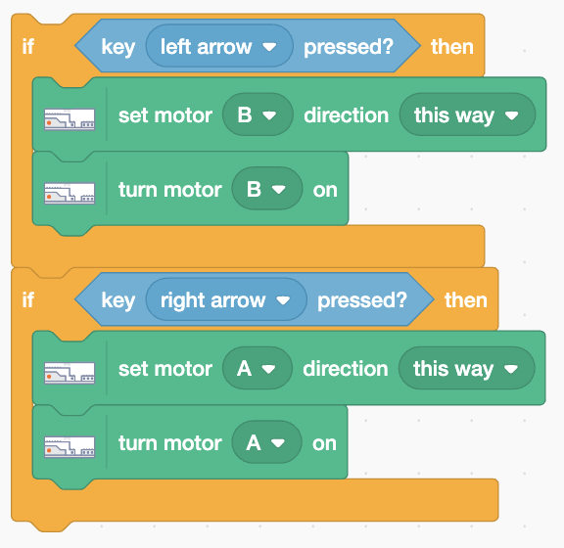
- Add code (right) at the end of
the loop to detect the left and right arrows. The left arrow turns on the right-hand motor (B). The right arrow turns on the left-hand motor (A).
Add reverse.
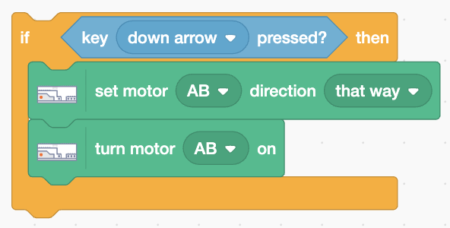
- Add code at the end of the loop that detects the down arrow
and sets the motor direction in reverse, or “that way”.
If the wheels skid then wrap elastic bands around them for better grip.
Save your code with a good name. File > Save now

