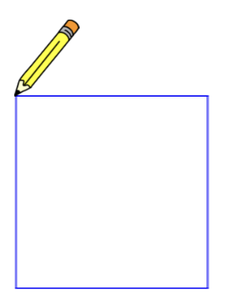

Shapes

Register/login at https://scratch.mit.edu
Remember to write down your password.


The Pen extension lets a sprite leave a trail when it moves.

- Click on the Add Extension button at the bottom left of the screen.
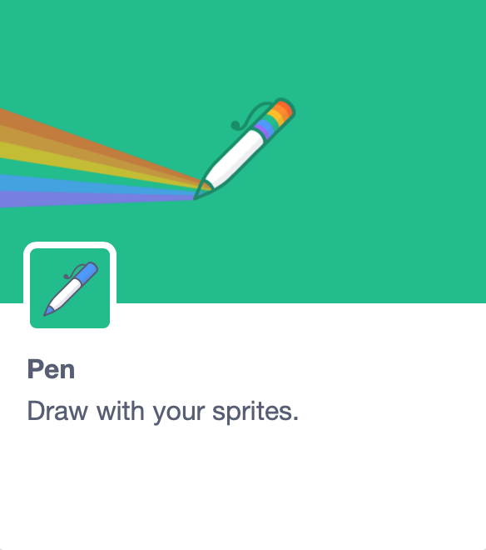
- Select the Pen extension. New Pen code blocks appear below the other code blocks.
- Choose a new sprite that looks like a pencil.
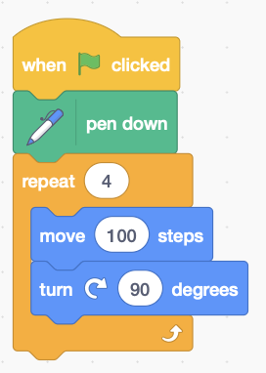
- On the costumes tab, select the whole pencil with the select arrow. Move the pencil so the tip is at the centre of the sprite (marked by a cross).
First draw a square.
- On the code tab, add the code (right) that starts drawing by putting the pen down. A square has 4 sides so the code repeats 4 moves. Each move is followed by a 90° (degree) turn at the corners.
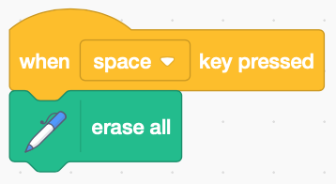
- You can clear the drawing with the erase all block when the space key is pressed.
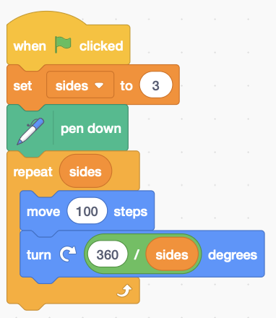
Now draw a triangle.
- Make a Variable for the number of sides (called sides) and set sides to 3.
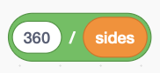
- Change repeat 4 to repeat sides so it works for any number of sides.
- Change the turn to

These shapes are called polygons.
Their external angles add up to 360° (degrees).
The turn is 360 divided by the number of sides.

What about shapes with more sides? (change sides)
The more sides there are, the more it looks like a circle!
Adjust the number of steps to keep the pencil on-screen.
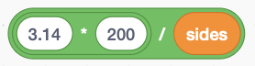
- Change the number of move steps to

The 200 is the width (diameter) of the polygon and this calculates the total number of steps (circumference) which can be divided by the number of sides.


A digon has only 2 sides – what does it look like?
Try changing the colour of the line.

Try changing the line thickness.
Remember to Save your code with a good name.
File > Save now

