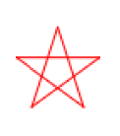

Seeing Stars

Register/login at https://scratch.mit.edu
Remember to write down your password.

Create your own code blocks to draw stars.
- Click on the Add Extension button at the bottom left of the screen.
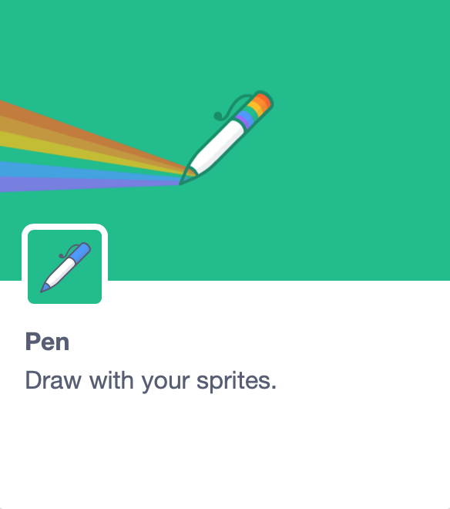
- Select the Pen extension. New Pen code blocks appear below the other code blocks.
- You can use any sprite but hide it with the show button in the sprite controls.
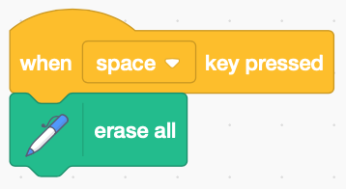
- Clear drawings with the erase all block when the space key is pressed.
Make a new block in My blocks.
- Click Make a block and input the block name star.
- Add an input (number or text) called sides.
- Add an input (number or text) called length.
- Add an input (number or text) called density.
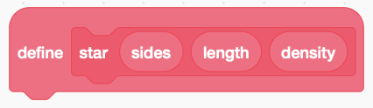
- Click OK.

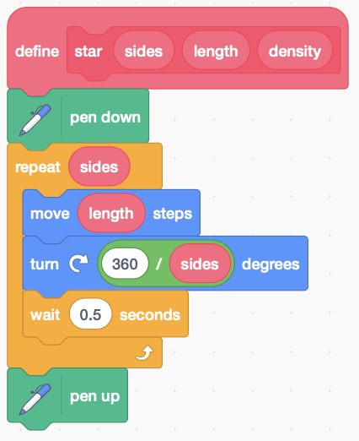
Start with a polygon (a many-sided shape). Drag sides and length from the define block into the code below it.
- Define the block with code (right) that starts by putting the pen down and ends with pen up. The repeated sides are a move length followed by a turn at the corners, and a short wait.
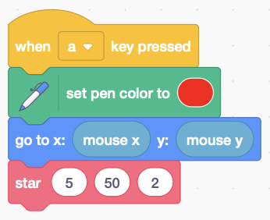
- When a key is pressed, set the pen colour and move the sprite to the mouse position. Then use the star block with 5 sides, length 50, and density 2 (we don’t use it yet).
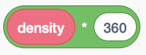
The external angles of a polygon add up to 360° (degrees), with a turn of 360 divided by the number of sides. Multiplying the turning angle by density makes the turns tighter, and the shape denser, like a star.
- In the turn replace 360 with to make stars.
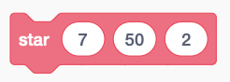
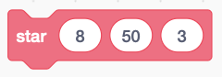
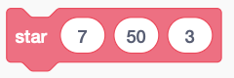
- Duplicate the code that uses your block and try different keypress and colour combos with different star numbers.
Try these numbers:

You could add a backdrop of “stars” on the stage.
Remember to Save your code with a good name.
File > Save now

