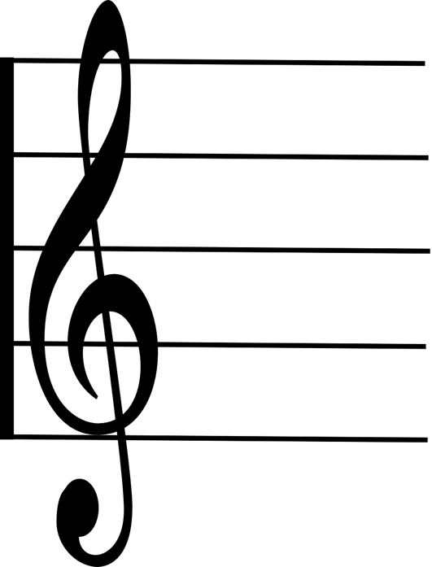

**Hap-py birth-day to you, hap-py birth-day to you.**

**G G A G C B G G A G D C**