**Buzz Wire**

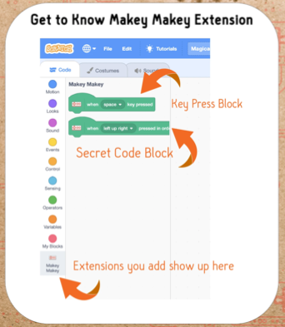

* Bend the long wire around the marker to form a shape.
* Stick each end in the block.
* Attach a crocodile clip.
* Connect to **space** on Makey

* Bend one end of the probe into a loop with a small opening.
* Attach a crocodile clip.
* Connect to **ground** on Makey.

**Scratch Code**

* Add code to detect a buzz wire contact: **when space key pressed**
* Click on the sound tab
* Choose a sound – search for “Buzz”
* **Play sound** on contact
* *Try some other sounds*

**Materials:**

* Makey Makey
* **15 Gauge 1.5mm Aluminum Craft Wire.**
* Cut the wire into lengths about 80cm long and roughen with emery cloth to make better contact.
* Cut 20cm off one end for the probe.
* Wooden blocks about 20cm long with a 1.6mm diameter hole drilled each end on one face.
* Board markers are a good size to bend the wire around.

