**Fruit Piano**

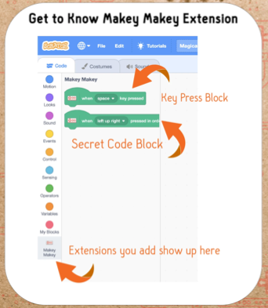

**Add the Music Extension**

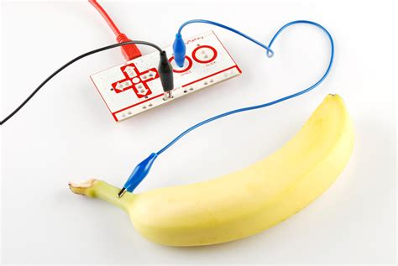

Stick a paper clip into the fruit to get a better contact.