**Makey-Mole**

***Whac-a-Mole*** *with an electric hammer.*

*Create your Scratch* ***Whac-a-mole*** *game first.*

* Add the Makey Makey extension
* In the first mole change **When this sprite clicked** to **when Makey key pressed**.
* A yellow cup with a blue ball next to it

  Description automatically generated with low confidenceYou want three moles side by side.
* For each mole select:
  + first mole is **left arrow**
  + Second mole is **up arrow**
  + Right mole is **right arrow**

*Now make three play-doh buttons   
(Play-Doh conducts electricity!)*

* **A picture containing headphones

  Description automatically generated**Take three blobs of Play-Doh and roll them into balls using the palm of your hand.
* Squish the Play-Doh balls into a flattish ‘pizza’ with the base of the tub.
* Squish a crocodile clip into each button and connect them to the three Makey inputs.
* Put the anti-static wrist-strap on the hand you want to play with.
* Connect the wrist-strap crocodile clip to earth.

*The hammer has a copper strip that completes the electric circuit.*

*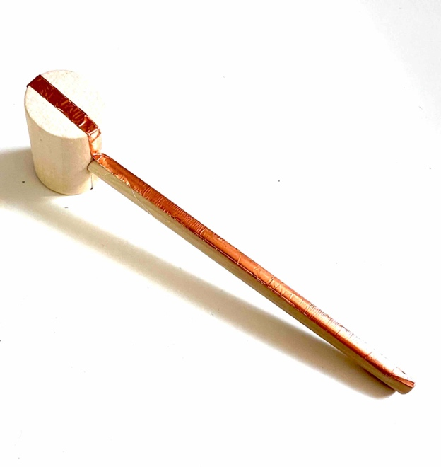When a mole appears, you must whack its Play-Doh button with the mallet.*

*An electrical circuit is created from the Makey input, through the Play-Doh button, along the mallet to your hand, through your body and down the wrist-strap to earth.*

**Materials:**

* Makey Makey
* **Tubs of Play-Doh**
* Anti-static wrist straps.
* 5mm wide Self Adhesive Copper Foil Tape
* Mini wooden mallets

*Prepare the wooden mallets by sticking a single length of copper foil along the length of the handle and around both faces of the mallet head***.**