**Honker**

https://makecode.microbit.org

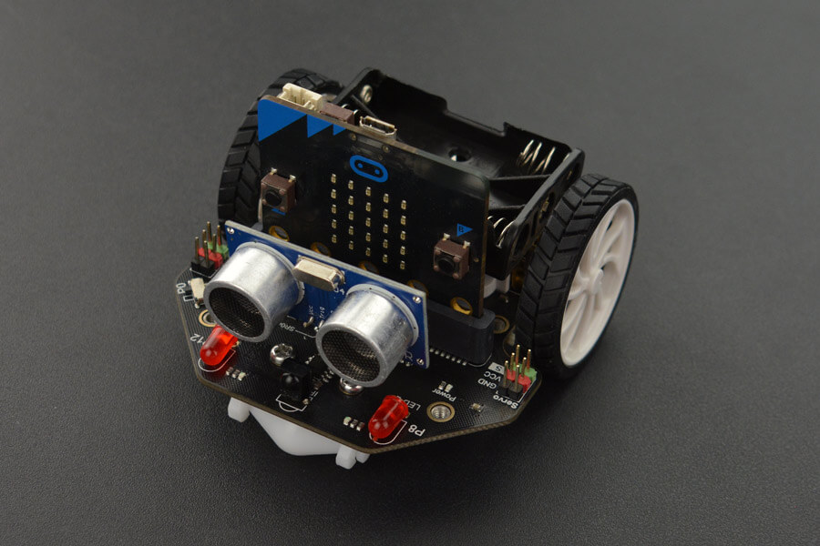Maqueen has a small piezoelectric speaker that can play musical tones.

Make it go honk-honk! (with a small pause in between) when you press a button.

Car horns (American ones anyway) are mostly in the pitch of F.

# **Honker**

1. Create the blocks code above
2. Connect the robot and download the code
3. Switch on the robot using the switch at the ‘tail’
4. Unplug the robot
5. Press button A.