**Magnetic Compass**

https://makecode.microbit.org

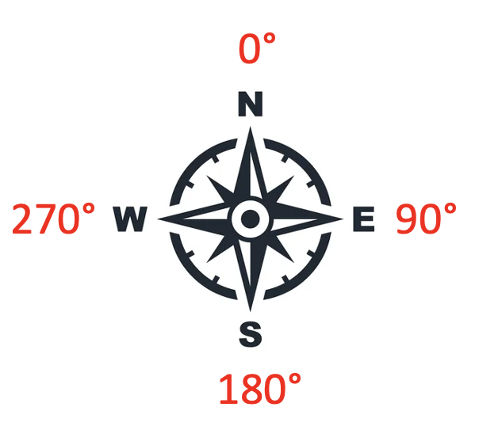

*The micro:bit has a built in magnetic compass  
 – which way is North?*

1. Open **https://makecode.microbit.org**
2. **+New Project**

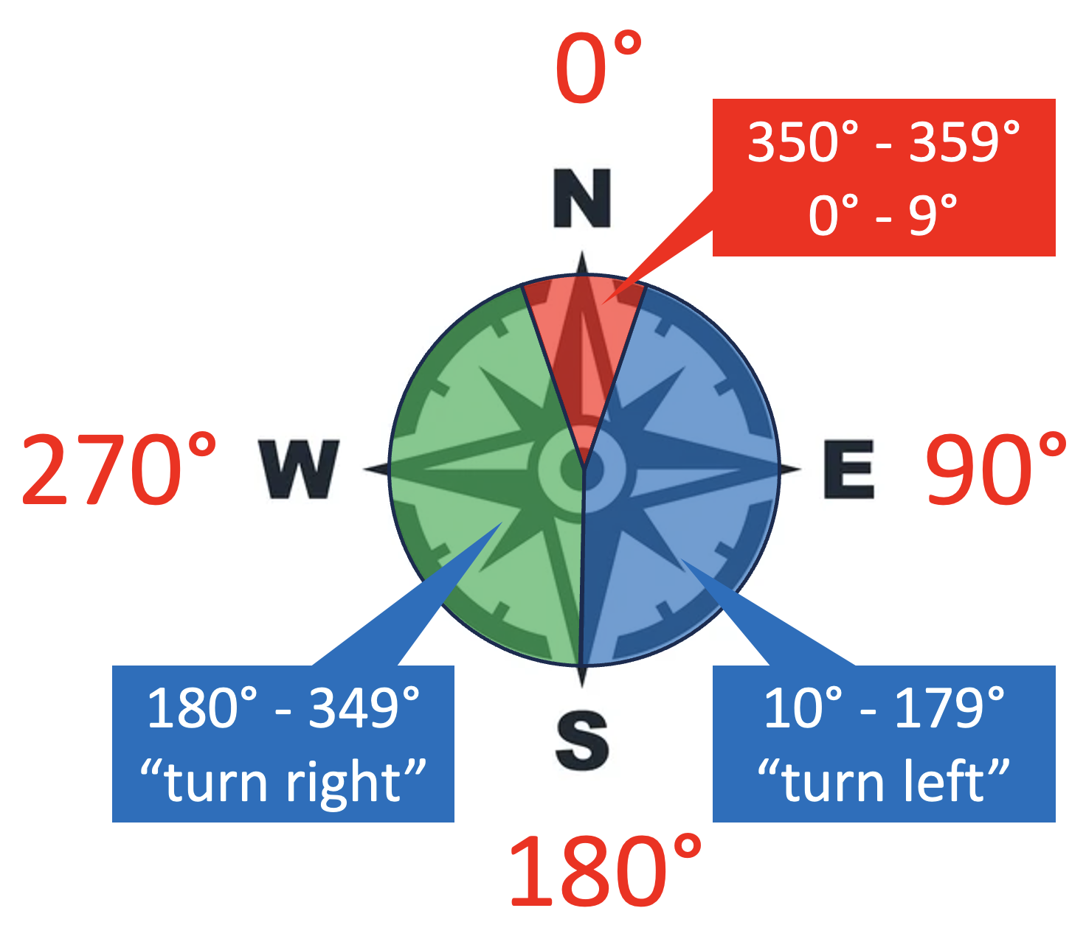

*There are 360 degrees in a circle. The micro:bit measures the****compass heading****from 0 to 359 degrees with its****magnetometer****.*

*When the compass heading is zero it’s pointing towards the North Pole. Allow around 10 degrees each side.*

1. Create a variable, **degrees**.
2. **Set degrees to the compass heading**
3. **Show** an upward **North** arrow **if** you’re in the red segment above.
4. 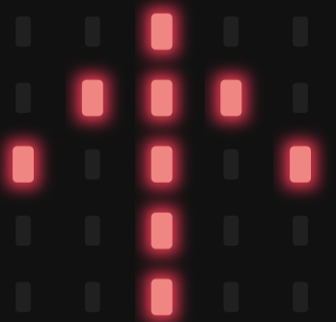Put the **OR** in first.
5. On one side of the **OR** put **degrees<10** (less than 10).
6. One the other side put **degrees≧350** (greater than or equal to)
7. 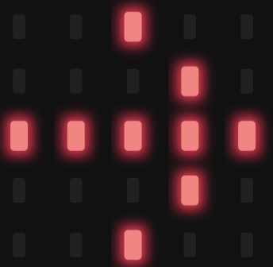Add more slots to the if block by pressing the + button at the bottom of the block.

*The if block now only has to distinguish between less than or greater than 180 degrees.*

1. 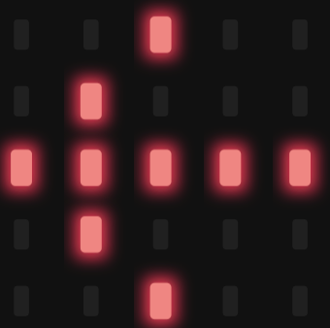Show an arrow pointing to the right (**show arrow East**)   
   if you’re in the green segment above, **else** **if degrees>180**
2. The *only* remaining case is the blue segment, so you don’t need another **if**, **else** **show arrow West** telling you to turn left.
3. Download the code to the micro:bit*.*

The code is over the page…

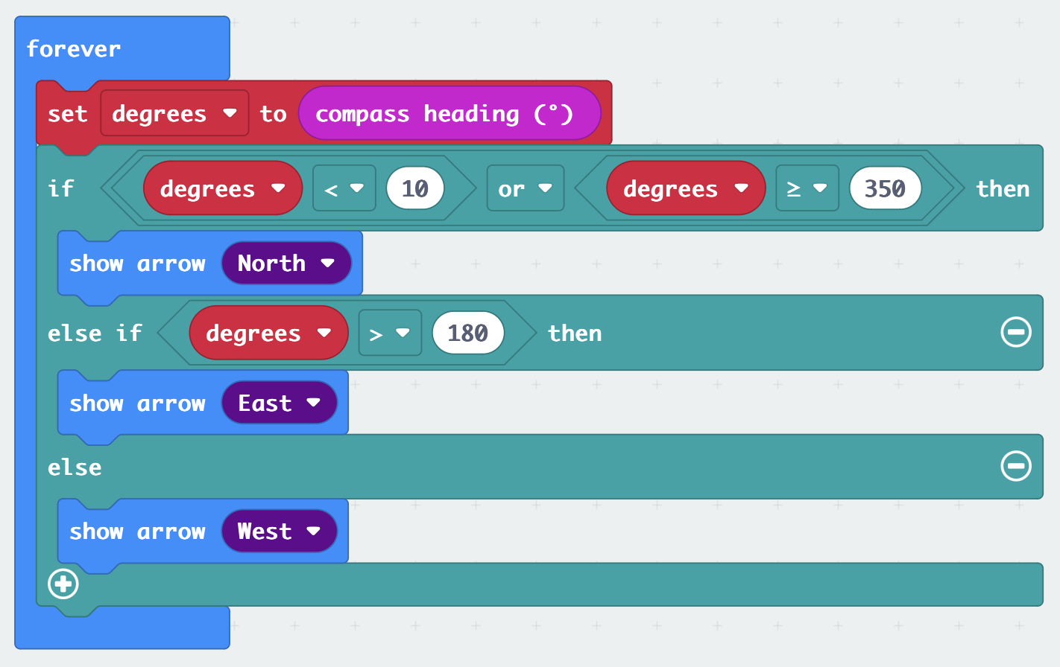

*Can you find the North Pole?*

***Save your code on a USB drive.***