Register at <https://makecode.microbit.org>

(The following is based on <https://wiki.dfrobot.com/micro_Maqueen_for_micro_bit_SKU_ROB0148-E>)

**Getting started**

* 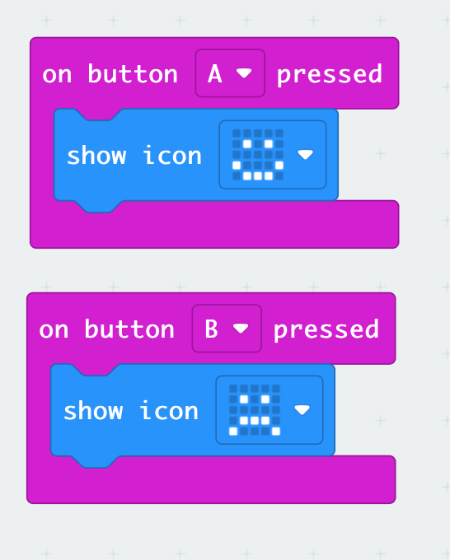New Project > enter your project name
* Create the Blocks code to the left
* Plug the USB cable into your computer
* Plug the other end into the micro:bit

The microbit is mounted as a drive on your desktop.

* Click Download
* Select the MICROBIT drive and Save
* “Download completed…” close the pop-up window.

Ignore any “Disk Not Ejected Properly” warnings.

**Import the maqueen library**



Click on the settings icon

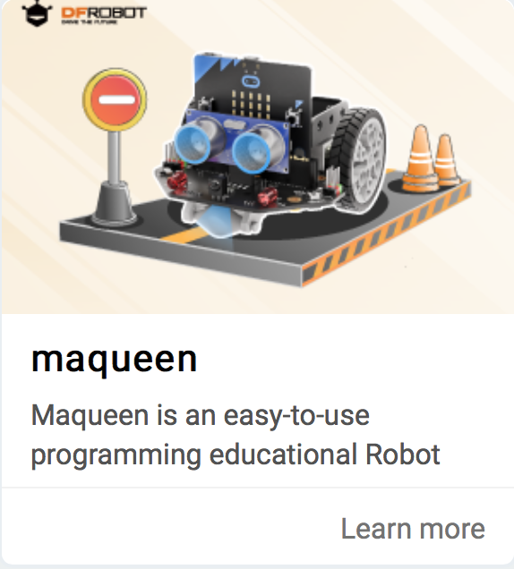

* Select Extensions > search for “maqueen”
* Select “macqueen” (not Maqueenplus)

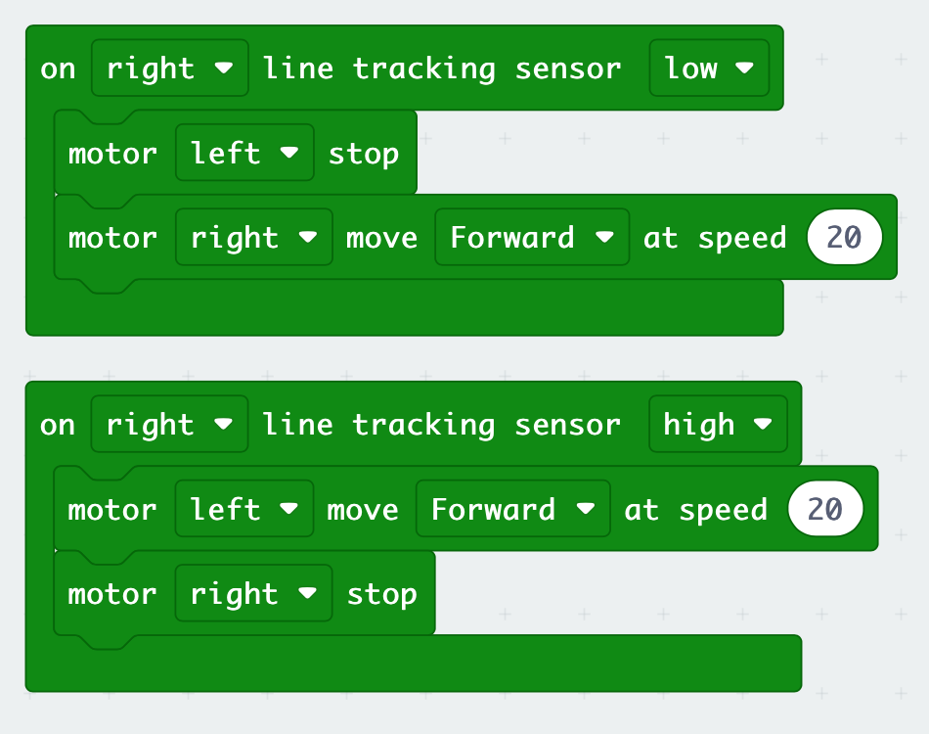**A simple line tracker**

* Create the blocks code to the left
* Connect the robot and download the code
* Switch on the robot using the switch at the ‘tail’
* Unplug the robot
* It should follow a black line.