

**Getting started**

* Using the **Chrome browser** Open https://makecode.microbit.org

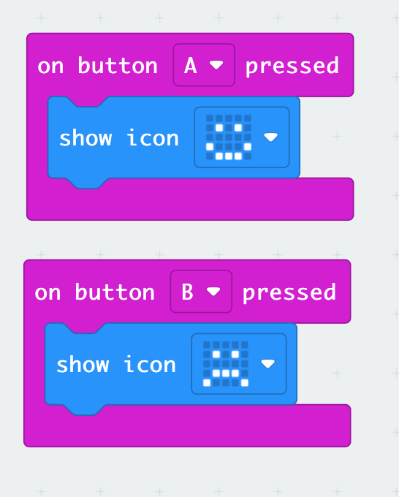

**Create a New Project**

**+ New Project** > enter your project name   
(e.g. **smile**)

Create the Blocks code to the left

* “on button” is under **Input**
* “show icon” is under **Basic**

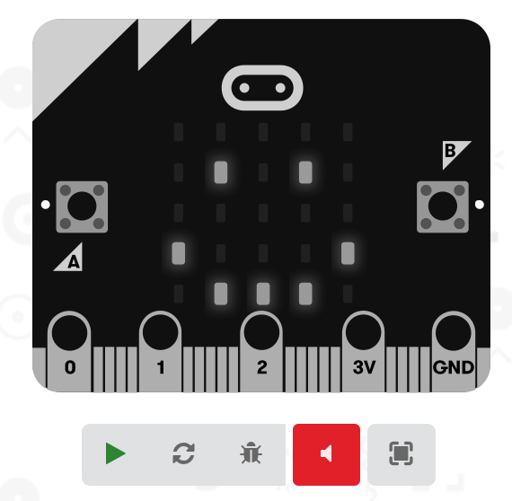

**Simulator**

You can run the program in the simulator

* Press the green triangle to start the simulator (it may be already running)
* Press the grey square to stop the simulator
* Try pressing buttons A and B

**micro:bit**

* Plug the USB cable into your computer
* Plug the other end into the micro:bit

Different ways to Download code to your micro:bit

# **Web USB (Chrome browser)**

1. Click on the 3 dots **…** next to **Download**
2. Select **Connect device**
3. Connect your micro:bit… click **Next**
4. Read the instructions about connecting to “BBC micro:bit CMSIS-DAP or DAPLink CMSIS-DAP”,click **Next** and select the right one.
5. Click **Done**

The download window may also say “Download your code faster by pairing with web USB”. Click **Pair Now.** Then go to step 3 above.

# **Download (Chrome browser)**

In your Chrome browser (you only need to do this once):

1. Click on the three dots at the top-right corner of the browser.
2. Select **Settings**
3. Click on **Advanced**
4. Select **Downloads**
5. Where is says Location, click **Change**
6. Select the MICROBIT (probably the D: drive), then **Select Folder**
7. Go back to the MakeCode tab in the browser

It should now download directly to your micro:bit

* Click **Download** (notice the lights flickering on the back of the micro:bit)
* A window pops up “Download complete…” When the micro:bit lights stop flashing, click **Done** in the pop-up window.

# Download (Safari browser)

The microbit appears like a USB drive when plugged in.

1. Click Download
2. Select the MICROBIT drive and Save
3. “Download completed…” close the pop-up window.
4. Ignore and **close** any “Disk Not Ejected Properly” warnings.

Scratch Link

<https://scratch.mit.edu/download/scratch-link>

Mac: open the App Store and search for “Scratch link”.

Run the app (you won’t see anything happen).

Open a browser and watch for the notification to install the Scratch Link extension.

Extensions appear next to the address bar

Click on the extension and give it permission to connect to scratch.mit.