

**Fluffy Dice**

https://makecode.microbit.org

The micro:bit can sense when it is being shaken.

* “on shake” is in **Input**
* To make a dice *variable*, click **Variables**, then click “**Make a Variable**”
* “set dice” will be in **Variables**
* “pick random” is in **Math**
* “show number” is in **Basic**
* Get the dice variable from **Variables**

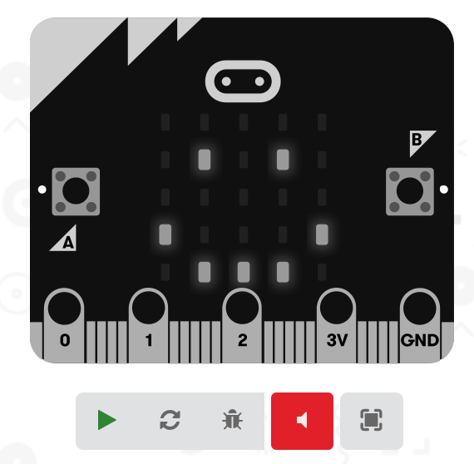

**Simulator**

You can run the program in the simulator

* Press the green triangle to start the simulator
* Press the grey square to stop the simulator
* A new ‘shake’ button will appear.

**micro:bit**

1. Plug the USB cable into your computer
2. Plug the other end into the micro:bit
3. Download the code to your micro:bit
4. Physically shake the micro:bit
5. What happens?