**Maqueen Robot**

https://makecode.microbit.org

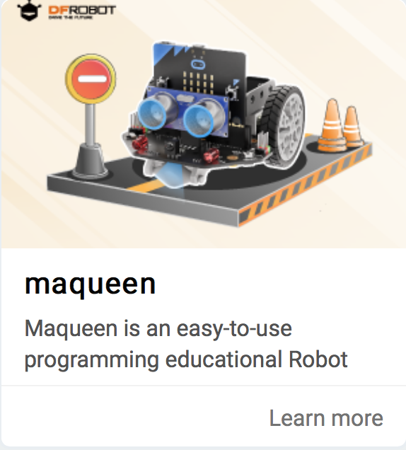

# **Importing the maqueen library**

1. Click on the settings icon
2. Select Extensions > search for “maqueen”
3. Click on “macqueen”   
   (**not** Maqueenplus)
4. See the new Maqueen functions

**Motors**

* Create the blocks code above
* Connect the robot and download the code
* Switch on the robot using the switch at the ‘tail’