**Edge Tracker**

https://makecode.microbit.org

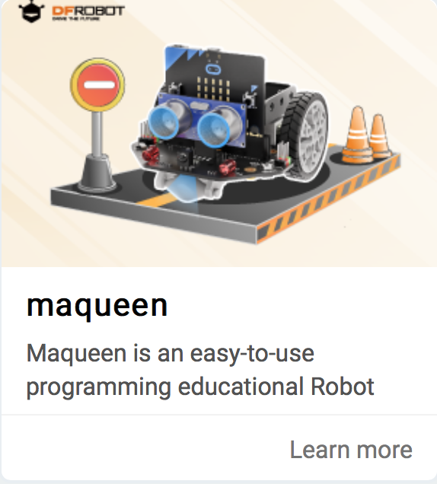

# **Importing the maqueen library**

1. Click on the settings icon
2. Select Extensions > search for “maqueen”
3. Click on “macqueen”   
   (**not** Maqueenplus)
4. See the new Maqueen functions

# **Simple edge tracker**

* Low indicates dark
* High indicates light
* Create the blocks code above
* Connect the robot and download the code
* Switch on the robot using the switch at the ‘tail’
* Unplug the robot
* It uses one sensor to follow a dark/light edge.

*Can you improve it?*

# **LED headlights**

You could use the LED headlights to indicate which way the robot is turning.

