**Honker**

https://makecode.microbit.org

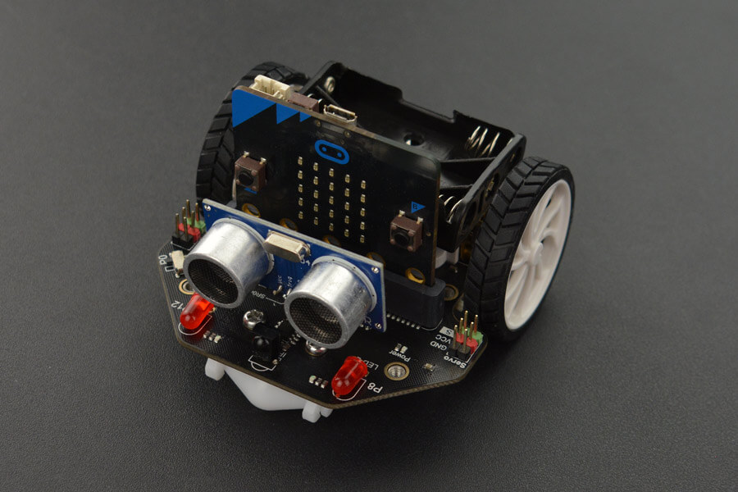Maqueen has a small piezoelectric speaker that can play musical tones.

Make it go honk-honk! (with a small pause in between) when you press a button.

Car horns (American ones anyway) are mostly in the pitch of F.

# **Honker**

* Create the blocks code above
* Connect the robot and download the code
* Switch on the robot using the switch at the ‘tail’
* Unplug the robot
* Press button A.