# **Scratch logo and symbol, meaning, history, PNGBubble Bomb**

Register/login at <https://scratch.mit.edu>

Preparation: Requires Scratch Link

*Make a bubble-wrap time-bomb. When the micro:bit is thrown from one person to another the timer counts down. Who will catch it when it ‘explodes’?*

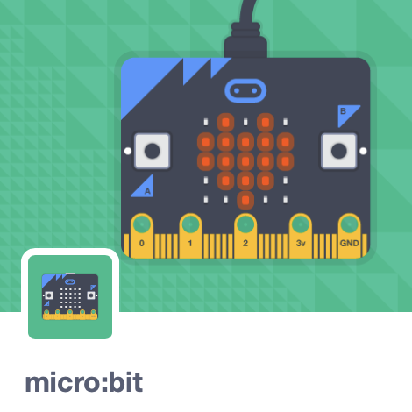

1. Create a new Scratch project and add the **micro:bit** extension.
2. Insert two AAA batteries into the battery pack, plug this into the micro:bit and turn it on at the switch.
3. Click on the 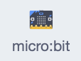 blocks section. If you see  at the top then connect the micro:bit.
4. Create a variable called **timer** for the countdown.
5. 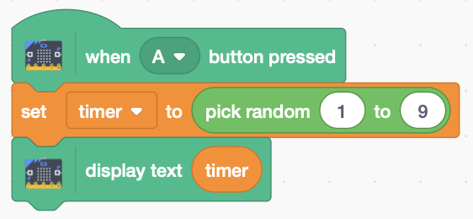Add the code (right) that initialises the **timer** to a random number.

*Try it out by pressing button A.*

1. 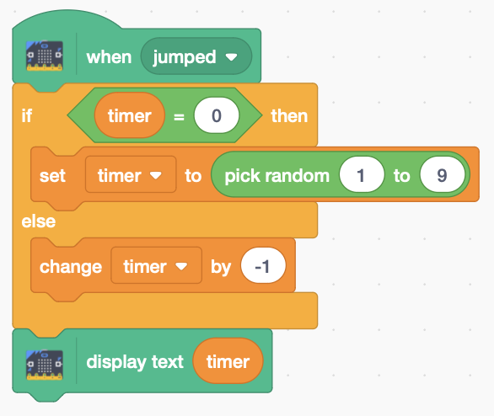 Add the code (right) that detects a jumping motion. The **timer** counts down to zero each time, when it’s randomised again.

*Try jumping up and down holding the micro:bit.  
Does it count down?*

1. Add sounds by selecting the **sounds** tab.
2. Choose a sound for the countdown. I chose the **Alert**.
3. Choose a sound for the explosion. I chose **Bonk**.
4. 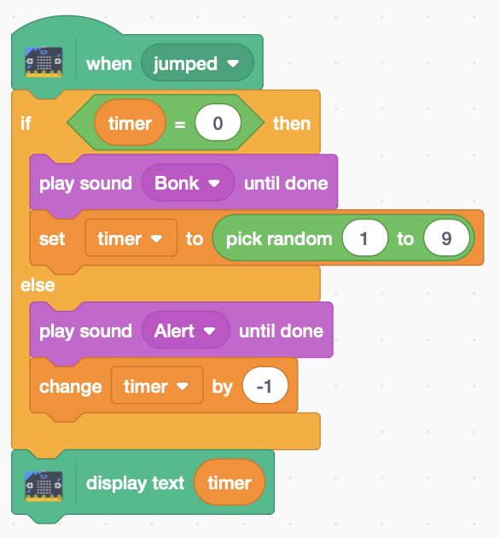Modifyyour code to **Play** these sounds at the right times. See the code (right) for example.

*Use bubble wrap to make your bomb safe to throw.*

1. Place your micro:bit and battery in a bubble-wrap pouch.
2. 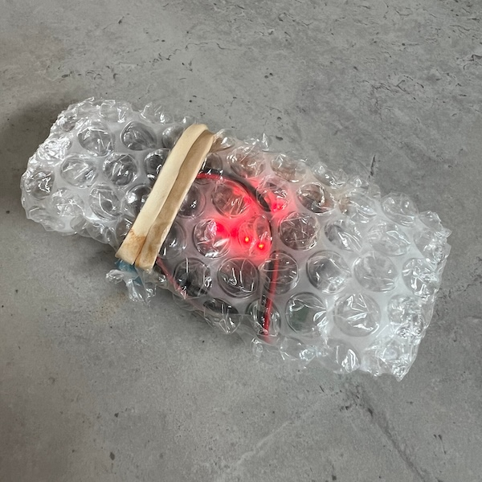Roll it up and stretch an elastic band around it.

***Gently*** *throw the bubble bomb to each other. You’re out of the game if it ‘explodes’ when it’s thrown to you.*

***Let a grown-up unplug the batteries – it’s not easy!*** *Save your code:* ***File > Save now***

***Materials***

* *Bubble-wrap pouches*
* *Elastic bands*
* *Micro:bit with battery pack (+2 x AAA batteries)*