# **Scratch logo and symbol, meaning, history, PNGMood Button**



Register/login at <https://scratch.mit.edu>

*Display emoji on the micro:bit using the buttons.*

1. 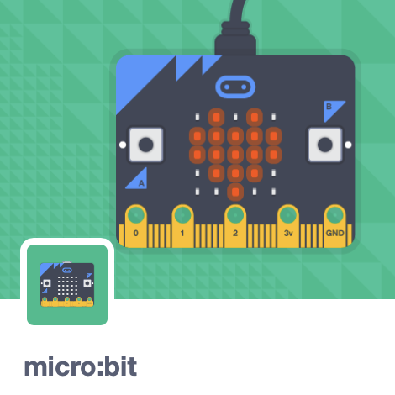Create a new Scratch project and add the **micro:bit** extension. The “Add Extension” button is at the bottom-left.
2. Plug the micro:bit into the PC with the USB cable.
3. Click on the new 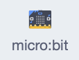 blocks section. If you see  at the top you have to connect the micro:bit.
4. 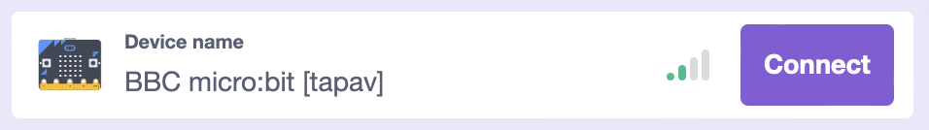Click on  to **Connect** the micro:bit:
5. Once it connects, clickto get back,   
   and you should now see a  at the top.

*The micro:bit has two buttons, A & B. Display a happy face if you press button A, and a sad face for button B.*

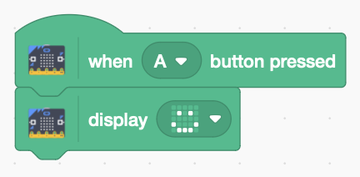

1. Add the following code. Click on the drop-down menu to choose the button.
2. 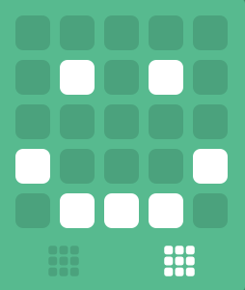Click on the drop-down in the display block to open the graphic editor. Draw a smiley face.
3. The code is automatically downloaded to the micro:bit. Try pressing **button A**.
4. 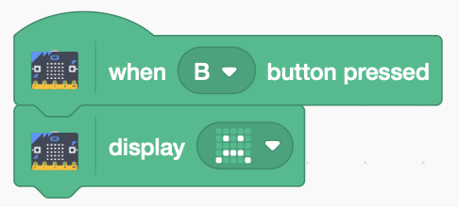 Duplicate the code. Change the copy to use button B, and edit the graphic to show a sad face.

***Save*** *your code with a good name.****File > Save now***

***Preparation***

1. *You need the micro:bit and a USB to USB-micro cable.*
2. *Install* ***Scratch Link*** *so Scratch can talk to the micro:bit.* [*https://scratch.mit.edu/microbit*](https://scratch.mit.edu/microbit)
3. *If Scratch Link is not already running (eg. after a reboot) search for and run the app. It appears on the menu bar.*
4. *Connect the micro:bit to the PC, with the USB cable. The micro:bit appears as a new drive (typically D: on a PC, or MICROBIT on a mac).*
5. *Download* ***micro:bit HEX*** *from the address above, and drag it to the micro:bit drive.*