# **Scratch logo and symbol, meaning, history, PNGMicro-Racer**

Register/login at <https://scratch.mit.edu>

Preparation: Requires Scratch Link

*A car racing game using the micro:bit tilt sensor.*

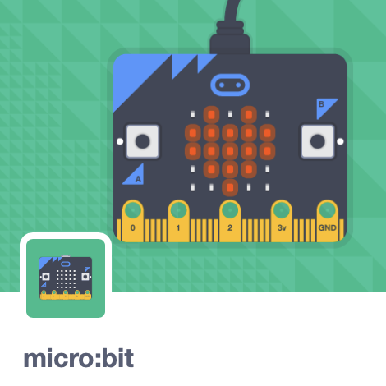

1. Create a new Scratch project and add the **micro:bit** extension.
2. Plug the micro:bit into the PC with the USB.
3. 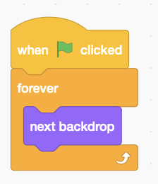Click on the 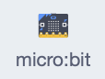 blocks section. If you see  at the top then connect the micro:bit.
4. Download road highway graphics from: https://codeclub67.github.io/images/highway.gif
5. Upload **highway.gif** to the stage.
6. Add stage code to cycle through the images.

stage code

1. 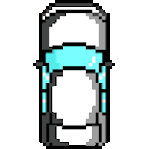 Download car graphics from:  
   https://codeclub67.github.io/images/microcar.gif
2. Create a new sprite from **microcar.gif**, set size to 35% and drag it near to the bottom of the screen.
3. 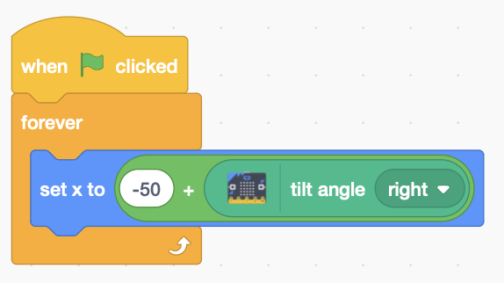Add the code to the microcar to steer left and right when the micro:bit is **tilted**.

*The offset of -50 shifts the car to the middle of the road when the micro:bit is held level and the tilt angle is zero.*

microcar code

1. 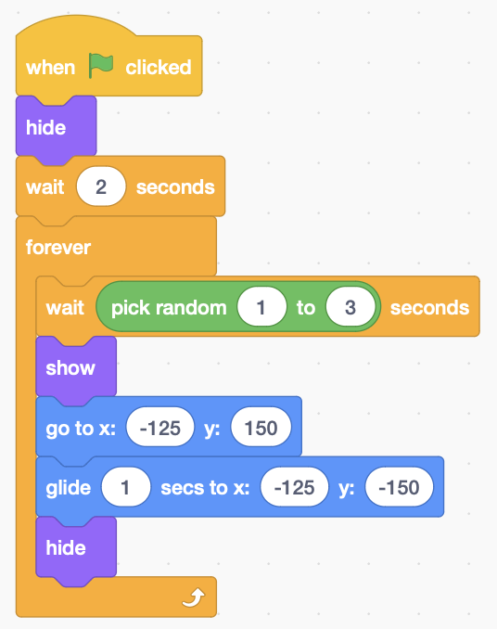Duplicate the sprite, choose the red car costume, and rename it “red car”.

*The red, green, and blue cars glide down from the top of the screen, as though you’re overtaking them.*

1. Delete any existing code from the red car and add code (right).   
   *x values of* ***-125*** *put it in the left lane.*

red car code

1. Duplicate the red car to make green and blue cars.
2. Change x values of the green car to **-50** for the middle lane, and to **25** for the blue car in the right-hand lane.
3. 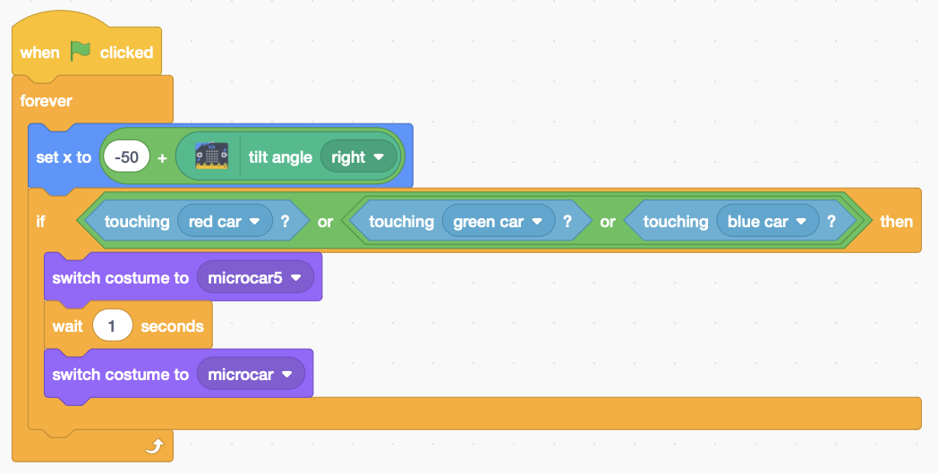Finally, extend the microcar sprite to detect car crashes and switch briefly to the explosion costume.

microcar code

***Save*** *your code with a good name.****File > Save now***