# **Scratch logo and symbol, meaning, history, PNGScratch-Snake**

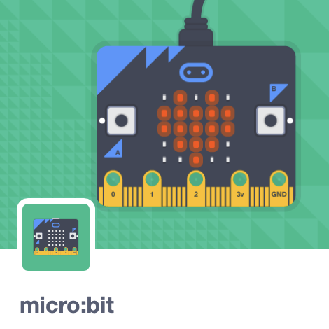Register/login at <https://scratch.mit.edu>

Preparation: Requires Scratch Link

*The classic ‘Snake’ game using the micro:bit   
tilt sensor. The snake cannot cross itself,   
and it grows longer when it eats!*

1. Create a new Scratch project and add the **micro:bit** extension.
2. Plug the micro:bit into the PC with the USB.
3.  Click on the 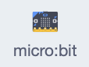 blocks section. If you see  at the top then connect the micro:bit.
4. 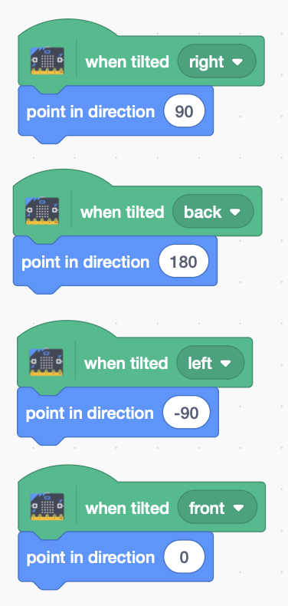Download snake graphics from: <https://codeclub67.github.io/images/snake.gif>
5. Create a new **snake** sprite with **snake.gif**.
6. Duplicate the sprite, and rename it **tail**.
7. Choose the body costume for the **tail**.
8. 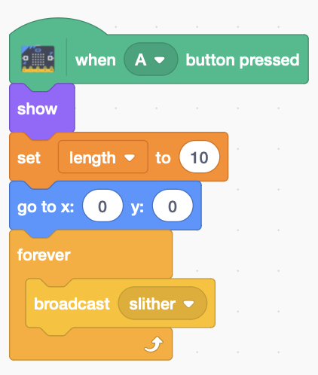Add code (right) to the snake head,   
   to change **direction** **when tilted**.

snake code

1. Add more snake code (left) using button A to start the game.
2. Create a **global** variable **length** (seen by all sprites), initially 10.

snake code

1. Broadcast a new message, **slither.**
2. 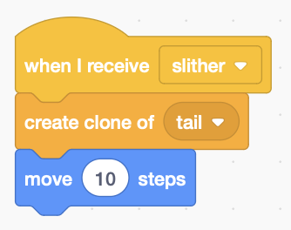Add **snake** code (right) to receive the message. It grows by **cloning** a **tail** as it **moves**.

snake code

1. 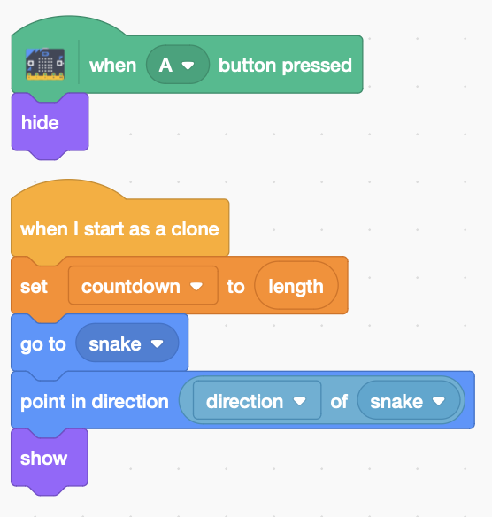 Create a countdown variable local to the **tail**.
2. Add **tail** code (left) that initialises **countdown** to **length**, and aligns its position and direction with the head. The tail, initially hidden, is then shown.

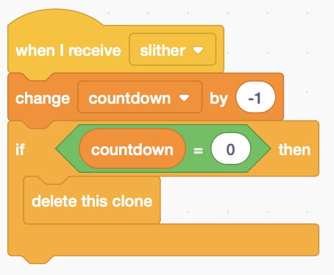

tail code

1. When the tail receives **slither** (right), it counts down, and deletes itself on zero.
2. 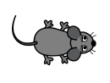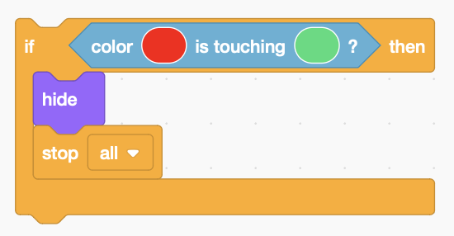Extend the snake’s ‘slithering’ code (left), ending the game when the snake’s red tongue touches the green of its own body.***Use the colour picker to get the right colours*.**

tail code

snake code

1. Choose a “mouse” sprite as snake food.
2. 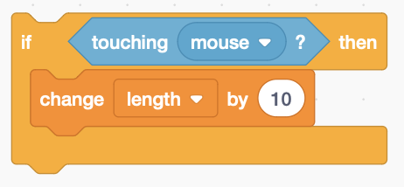Extend the **snake** ‘slithering’ code again (right), detecting when it **touches** the **mouse,** growing in **length**.

snake code

***Save*** *your code with a good name.****File > Save now***