# **Scratch logo and symbol, meaning, history, PNGScratch-Synth**

Register/login at <https://scratch.mit.edu>

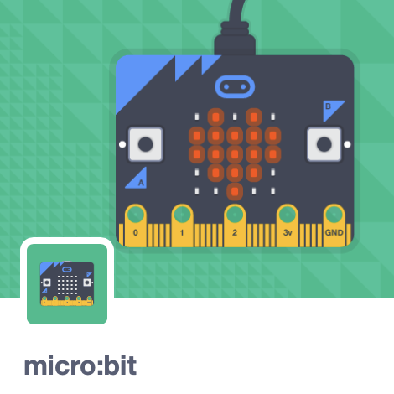

*Create a music synthesiser with the micro:bit.*



1. 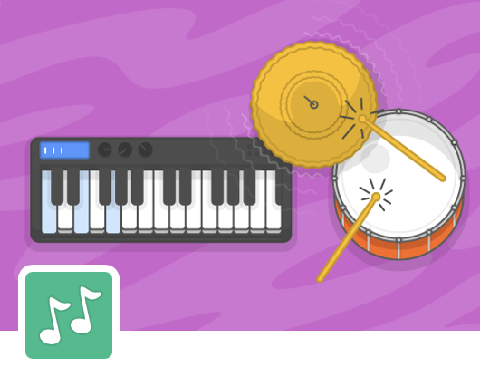Create a new Scratch project and add the **micro:bit** extension.
2. Also add the **Music** extension.
3. Plug the micro:bit into the PC with the USB cable.
4. Click on the new 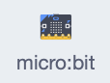 blocks section. If you see  at the top you need to connect the micro:bit.
5. 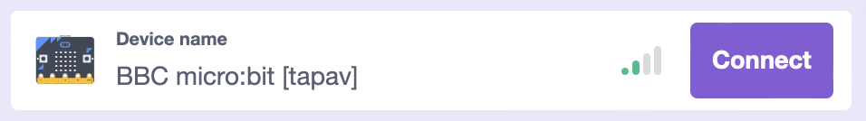Click on  to **Connect** the micro:bit. If more than one device is shown look for the name matching the one on the micro:bit display (“tapav” in this example).
6. Once it connects, clickto get back,   
   and you should now see a  at the top.

*The micro:bit can detect* ***tilt*** *left/right and front/back. Use this to change the pitch and volume of a sound.*

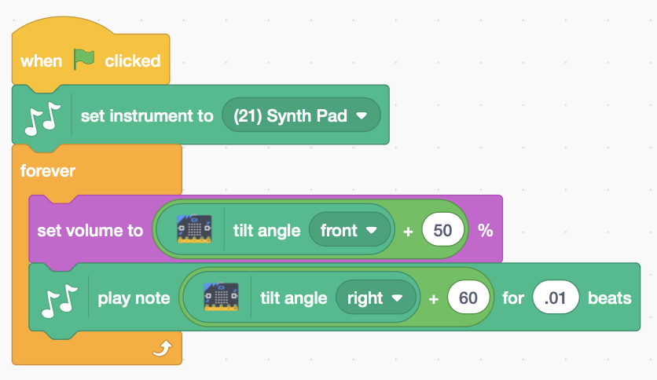

1. Add the following code.

* The tilt values are 0 when the micro:bit is level.
* The volume is a percentage (%) so add offset 50 to make the volume 50% when it’s held level.
* A note of 60 is “Middle C” so add offset 60 to make this the note when it’s held level.
* 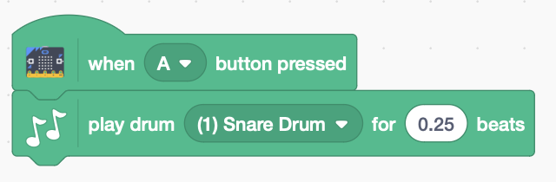Try different instruments

1. Use buttons A and B to add percussion.

***Save*** *your code with a good name.****File > Save now***

***Preparation***

1. *You need the micro:bit and a USB to USB-micro cable.*
2. *Install* ***Scratch Link*** *so Scratch can talk to the micro:bit.* [*https://scratch.mit.edu/microbit*](https://scratch.mit.edu/microbit)
3. *If Scratch Link is not already running (eg. after a reboot) search for and run the app. It appears on the menu bar.*
4. *Connect the micro:bit to the PC, with the USB cable. The micro:bit appears as a new drive (typically D: on a PC, or MICROBIT on a mac).*
5. *Download* ***micro:bit HEX*** *from the address above, and drag it to the micro:bit drive.*