**Maqueen Robot**

https://makecode.microbit.org

# **Add the maqueen library**

1. **+New Project**
2. Select +Extensions > click “maqueen”  
   (**not** Maqueenplus)
3. See the new Maqueen functions

**Forwards and Backwards**

*This code (right) moves the robot forward then backward.*

1. Create the blocks code above to move the robot **forward** then **backward**.
2. Connect the robot and download the code
3. Unplug the robot
4. Switch the robot on with the switch at the ‘tail’

**Going in Circles**

*Change your code to go round in ‘circles’.*

1. 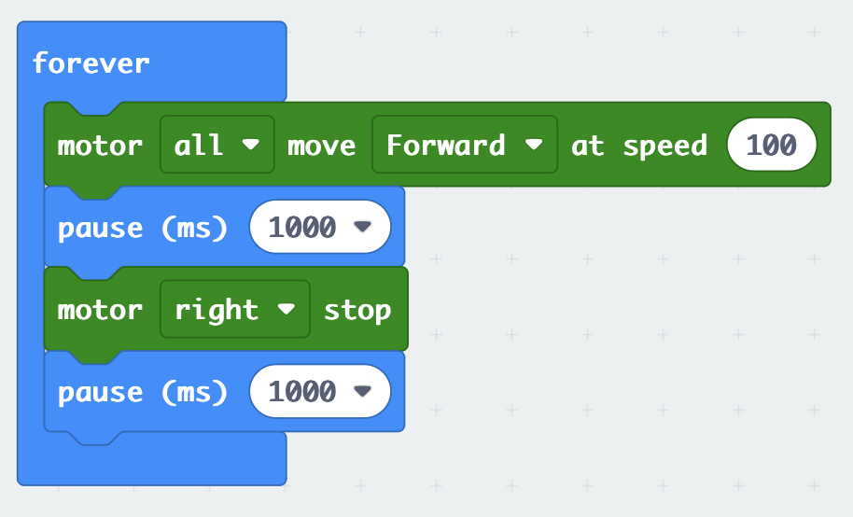Change your code so that it moves forward a bit, stops, then turns by driving one wheel (left wheel) while the other (right wheel) is stopped.

**Save your code to a USB stick.**

***Chrome setup to download code directly to the micro:bit***

*In your Chrome browser:*

**

1. *Click on the three dots at the top-right corner of the browser.*
2. *Select* ***Settings***
3. *(Click on**Advanced****) may not be needed on later versions***
4. *Select* ***Downloads***
5. *Where is says Location, click* ***Change***
6. *Select the MICROBIT (probably the D: drive), then* ***Select Folder***
7. *Uncheck* ***“Ask where to save”***
8. *Uncheck* ***“Show downloads when they’re done”***
9. *Go back to the MakeCode tab in the browser*

*It should now download directly to your micro:bit.*