**Ultrasonic Bat-Sense**

*Use a high-pitched* ***ultrasonic*** *sound sensor – like bat echo-location.*

# Open **https://makecode.microbit.org**

# **+New Project**

1. Select +Extensions > click “maqueen”  
   (**not** Maqueenplus)
2. Plug the ultrasonic sensor into the 4-pin socket near the front of the robot.

# **Ultrasonic echo-location**

1. In Variables, make a variable called **distance**
2. Add the code to the right
3. Download to the robot and wait until the amber light stops flashing.
4. Don’t unplug the robot,   
   but turn it on otherwise the sensor won’t work.

*This shows the distance in centimetres (cm) on the display. Use it to detect your hand in front of the robot.*

* *How close can you get an accurate distance?*
* *How far away does it reliably detect you?*
* *Try holding your hand at different angles. What works best?*

**Obstacle Avoidance**

*Use the ultrasonic sensor to avoid crashing into objects.*

1. Try the following code to detect an obstacle, move back, turn, then carry on.

*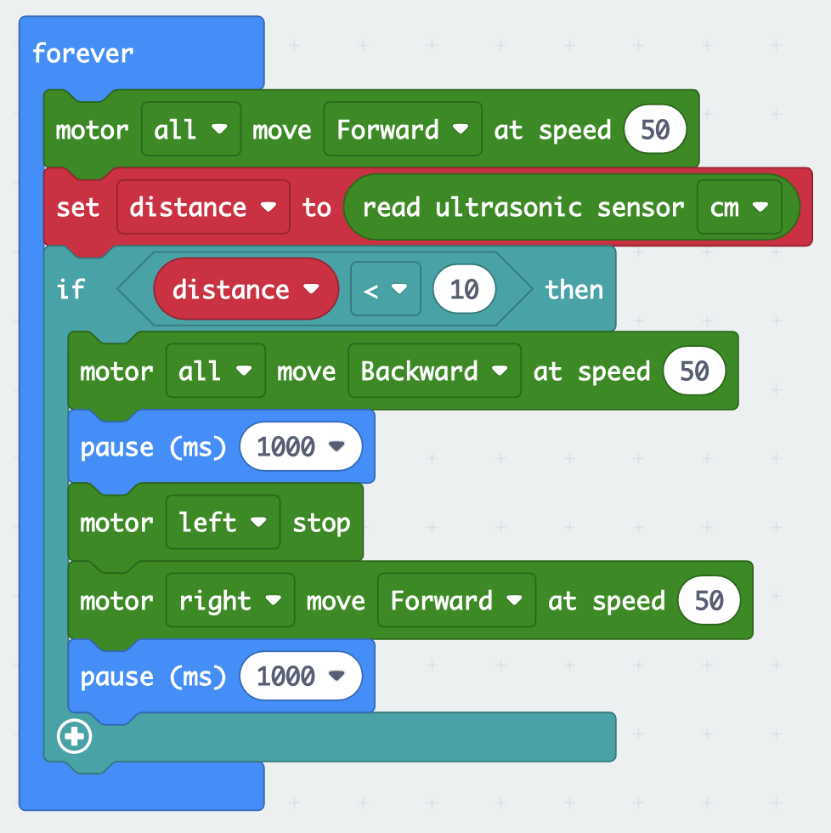We have to remove* ***show number*** *because it’s too slow*.

* 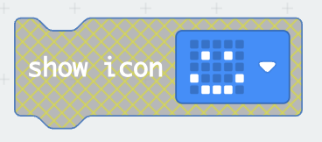*Try showing icons to see what the robot is doing*.
* **Save your code to a USB stick.**