**Edge Tracker**

https://makecode.microbit.org

*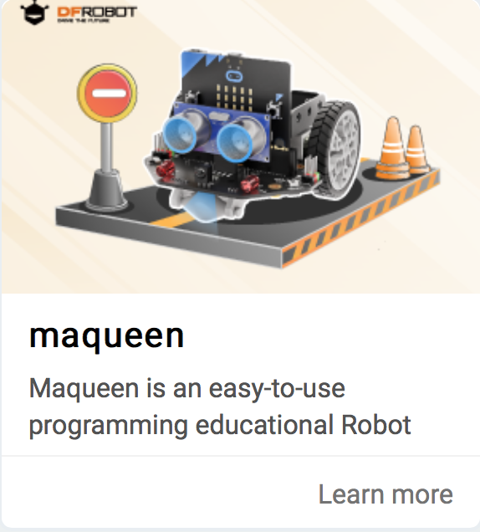Make a robot follow the edge of a track*

# **Import the maqueen library**

1. Open **https://makecode.microbit.org**
2. **+New Project**
3. Select +Extensions > click “maqueen”  
   (**not** Maqueenplus)

# *Hold the robot over the black track and move it left and right. See the blue lights on each side switch off when it’s held over the track.*

*The robot has a pair of* ***infra-red******reflectance*** *sensors you can see underneath.*

# **Simple edge tracker**

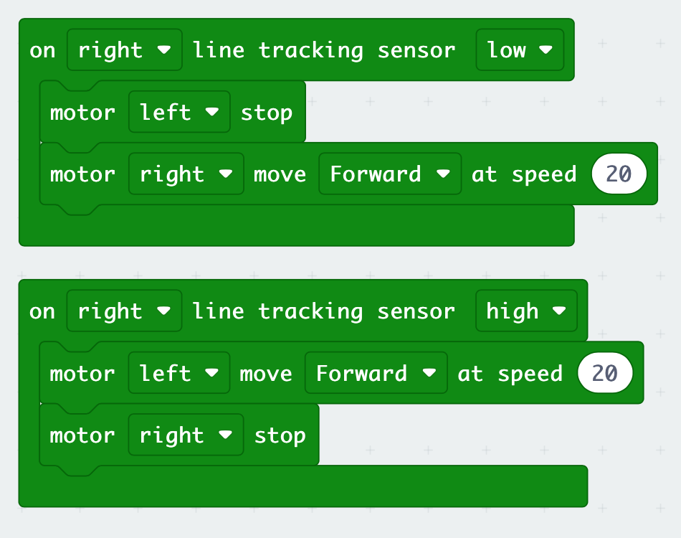*Use the right (or left) sensor to see if the robot is on or off the line.   
Run just the right motor to steer left, and just the left motor to steer right.*

* **Low** indicates the dark track
* **High** indicates white off-track

1. Add the code (left)
2. Connect the robot and download the code
3. Switch on the robot using the switch at the ‘tail’
4. Unplug the robot
5. Place it on the track

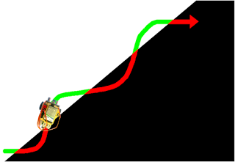*Watch it weave its way along the edge of the track*

*Try changing the speed. How fast can it go without coming off the track?*

# **LED headlights**

Use the LED headlights to show which way the robot is turning.

1. A screenshot of a computer

   Description automatically generated with low confidenceAdd extra **LEDlight** instructions to your code, to turn the headlights on and off.

*.*

***Save your work to a USB drive.***