**Edge Tracker**

https://makecode.microbit.org

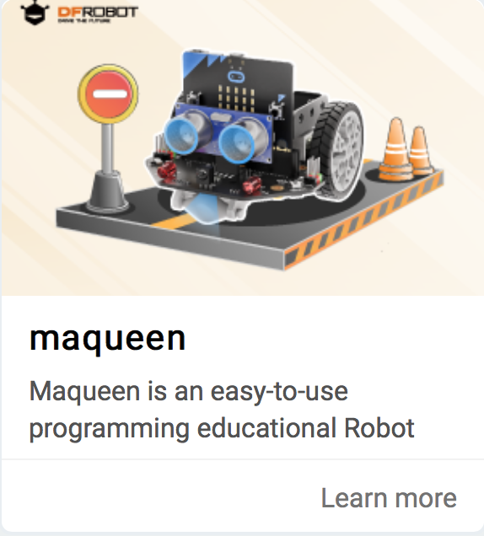

# **Importing the maqueen library**

1. Click on the settings icon
2. Select Extensions > search for “maqueen”
3. Click on “macqueen”   
   (**not** Maqueenplus)
4. See the new Maqueen functions

# **Simple edge tracker**

* Low indicates dark
* High indicates light

1. Create the blocks code above
2. Connect the robot and download the code
3. Switch on the robot using the switch at the ‘tail’
4. Unplug the robot
5. It uses one sensor to follow a dark/light edge.

*Can you improve it?*

# **LED headlights**

You could use the LED headlights to indicate which way the robot is turning.

