# Scratch logo and symbol, meaning, history, PNG/var/folders/f1/9jg6q1ps55z27yrv25hgvj44041s1n/T/com.microsoft.Word/WebArchiveCopyPasteTempFiles/bot1.png

**Robot Wars 2**

1. Download bot1 & bot2 designs:

* <https://go.uwe.ac.uk/bot1>
* <https://go.uwe.ac.uk/bot2>

1. 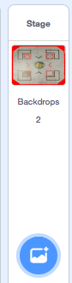Create two identical sprites that bounce around the stage.
2. You can use the images above as *costumes* for your sprites.
3. Adjust the costume size.
4. Can you detect when the two sprites touch?



1. When they touch, broadcast a message
2. When they touch, perform an action:



Here’s one solution. Each sprite can have similar code:

