# Chart Description automatically generated with low confidenceScratch logo and symbol, meaning, history, PNG

**Breakout**

Register/login at <https://scratch.mit.edu>

*You have a bat and ball and have to knock out the bricks.*



1. Graphical user interface, text, application, chat or text message

   Description automatically generatedMake the bat. Create a new sprite and use **paint** to draw a rectangle in the centre.
2. Use the mouse to control the bat. Move the bat to the bottom of the screen and add code that **sets the x** (horizontal) position to **mouse x** in a loop.
3. A black circle with a white background

   Description automatically generated with medium confidenceMake a ball. Create a new sprite and use paint to draw a circle in the centre.
4. Graphical user interface, text, application, chat or text message

   Description automatically generatedAdd code to make the ball bounce around the screen. Make sure the ball is **show**ing and then **move** the ball inside a loop. Add “**if on edge, bounce**” to bounce off the edges.
5. **Graphical user interface, application

   Description automatically generatedHide** the ball if it gets past the bat. Add an **if** block to the loop to detect when the vertical (y) position of the ball nears the edge, before it bounces. Experiment with the y position.

1. When the ball is **touching** the **bat** it has to bounce off. Add an **if** block that changes the ball **direction**, subtracting it from 180° (180 degrees is half a circle).
2. Shape, square

   Description automatically generatedGraphical user interface, text, application, chat or text message

   Description automatically generatedGive the player more control over the bounce by adding the horizontal (x) difference between the ball and the mouse, to the direction.  
   Add this inside the **if** block above.
3. Make a brick. Create a new colourful square sprite.
4. Diagram

   Description automatically generatedThe brick will disappear when the ball hits it. Use **wait until touching Ball**.
5. To make the ball bounce off the brick, broadcast a ‘pong’ message to the ball.
6. 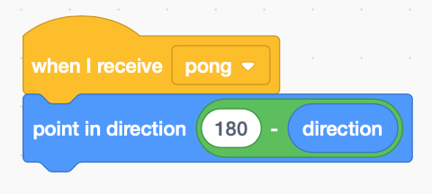When the ball **receives** the pong message it bounces the same way it bounced off the bat.

*Click on the green flag to restart the game.  
Duplicate more bricks. Try adding a score.*

***Save*** *your code with a good name.* ***File > Save now***