# Scratch logo and symbol, meaning, history, PNG

**DigiDoll**

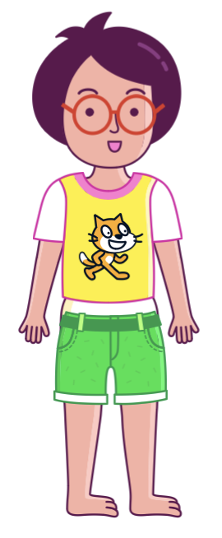

Register/login at <https://scratch.mit.edu>

*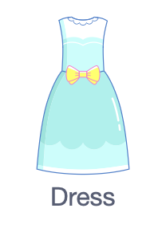Make a digital dressing-up doll.*

1. Choose a sprite by selecting “**Harper**”.

*Dress Harper to go to a party.*

1. Choose the **Dress** sprite in **fashion**.
2. 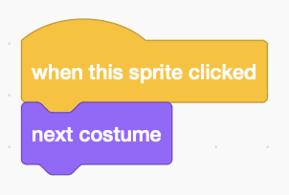Drag the dress onto Harper.
3. Make the dress change when you click on it by adding this code to the dress.

*You need a good party backdrop, and different backdrops for different situations.*

1. Click on the Stage and select a backdrop for a **party**.
2. Add a button sprite and edit the costume, with the text tool **T** to add a “party” label.
3. 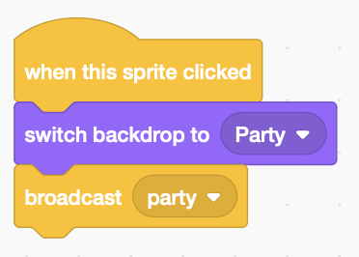Add code to the party button that **switches** to the party backdrop and **broadcasts** the change to other sprites.
4. 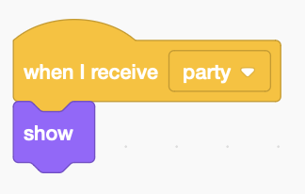Add code to the dress that **receives** the message, and **shows** the sprite.

*Add backdrops and new clothes for different situations. What works for school?*

1. ****Click on the Stage and choose a backdrop for **school**.
2. Add a button and edit the text to ‘**school’.**
3. 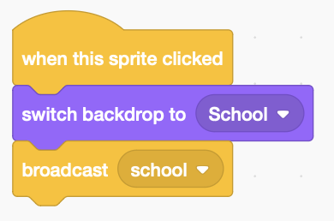On the school button add code to **switch** to the school backdrop and **broadcast** the change, like before.
4. 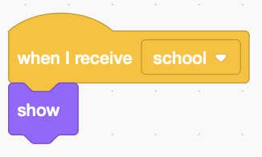Choose **fashion** items to wear to school, such as the **Shirt**.
5. 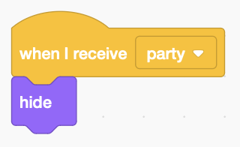For each item of school clothing, **show** it when it **receives** the **school** message.
6. For each item of school clothing, **hide** it when it **receives** the **party** message.
7. 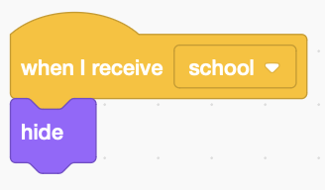Don’t forget to **hide** party clothing when it **receives** the **school** message.

*Try adding a new design to the* ***Shirt*** *sprite.*

1. 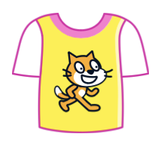Duplicate the original Shirt costume.
2. Edit the duplicate, selecting and deleting the existing design.
3. Choose another costume for the new design.
4. Select and copy the costume.
5. 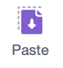Go back to the blank Shirt and paste in the new design.   
   You may have to resize it.
6. Finally, delete the costume you used in the design.

*Remember to* ***Save*** *your code.*