*Scratch logo and symbol, meaning, history, PNG

**Dragon Kite**

Register/login at <https://scratch.mit.edu>

*Dragon kites are traditional Chinese kites with long tails.*

1. A picture containing text, clipart

   Description automatically generatedDownload the dragon images from:  
   <http://codeclub67.github.io/images/dragon.gif>
2. Create a new sprite for the dragon by uploading the dragon images.
3. A screenshot of a computer

   Description automatically generated with low confidenceSelect the dragon’s head costume.

*The kite blows randomly in the wind*

1. When the code starts, the head should appear on the **front layer**. In a **forever** loop, it’s blown to a **random position**.
2. 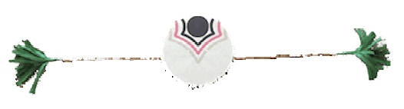Duplicate the dragon’s head.
3. In the new sprite, select the tail costume.

*Tail sections are strung together.*

1. Graphical user interface, text, application, chat or text message

   Description automatically generatedMake the tail **glide** quickly (0.1 secs) towards the sprite in front.   
   The first tail follows the head.
2. A picture containing text, sign, screenshot

   Description automatically generatedDuplicate the tail a few times   
   (7 times looks good). Make each one **glide** to the tail segment ahead of it.
3. The **last** tail is sent to the **back layer**.

*To send each tail sprite to its own layer, send it to the back and move it forward as many layers as needed.*

1. The last-but-one tail is sent to the **back**, and then **forward** 1 **layer**.   
   The next one is sent back 2, and so on…

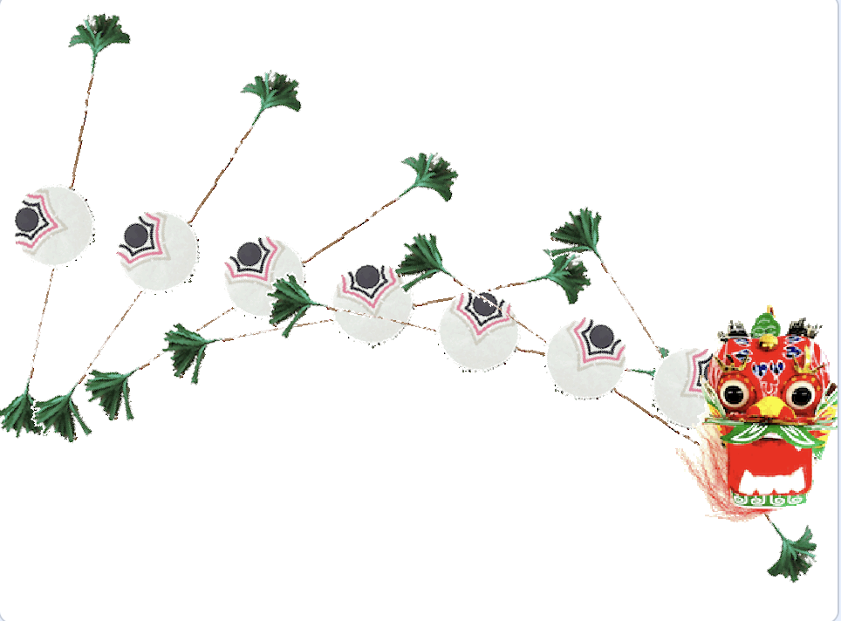*The kite twists and turns in the wind*

*Turn each tail as it moves across the screen, from 0 at the left edge,   
to 180 degrees at the right edge.*

* *The x position for the screen edges are -240 and 240.*
* *Divide x by 240 to get a number from -1 to 1.*
* *Times by 90 to get an angle from -90 to 90 degrees.*
* *Add 90 degrees to offset it from 0 to 180 degrees.*

1. *Graphical user interface, text, application, chat or text message

   Description automatically generated*Add this code inside the loop of each tail sprite.

*Try making the head of the kite follow the mouse pointer.*

***Save*** *your code with a good name.* ***File > Save now***