# Scratch logo and symbol, meaning, history, PNG

**Ghosts**

Register/login at <https://scratch.mit.edu>

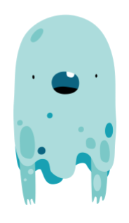

*Use the ghost effect.*

1. **Create** anew Project and give it a name.
2. In the **Sprite** section, **choose a sprite**. Look for the ‘Fantasy’ **Ghost** character. Keep Scratch the Cat for now.
3. Look for a **background** for a haunted house or forest.

1. Add code to **Scratch the cat** that loops **forever** and **moves** it to the mouse pointer.
2. Now make the **ghost** *ghostly*. Add a **start** block and **set ghost effect** to 50 percent (%) to make it half visible.
3. **A screenshot of a computer screen

   AI-generated content may be incorrect.**Add a **forever** loop and inside the loop make the Ghost **glide** towards the cat, taking a **random** number of seconds from 1 to 3.
4. A screenshot of a computer screen

   AI-generated content may be incorrect.Add another loop to make the Ghost sense when it’s **touching** the cat, and **if** they touch, **say** “Woooooh! ” as ghosts do.

**Fade in and Fade out**

*The****timer*** *records how much time, in seconds, have passed since the last time the green flag was clicked.*

*A sinewave is a wavy line we can use with the Scratch* ***sin*** *function. Use it to vary the ghost effect over time. Multiplying* ***timer*** *by 100 changes the frequency of the wave.*

*The peaks of the wave are equal to 1, and the troughs to -1. Multiply by 50 so it swings from -50 to +50, then finally add 50% for a ghost effect ranging from 0% to 100% invisibility.*

1. 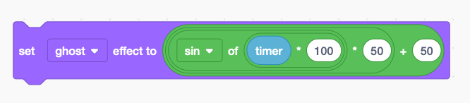Make the ghost fade in and out with by adding this block to the loop above: 50 + ( **sin**( **timer** * 100) * 50)
2. Now try duplicating the ghosts (right-click the sprite).

***Save*** *your code with a good name.*