# Scratch logo and symbol, meaning, history, PNG

**Scratch Invaders**

Register/login at <https://scratch.mit.edu>

*Make the invaders line dance in a row.*

1. Download *invader* images from:  
   <https://codeclub67.github.io/images/invader.gif>
2. Create a new sprite by uploading the *invader* images.

*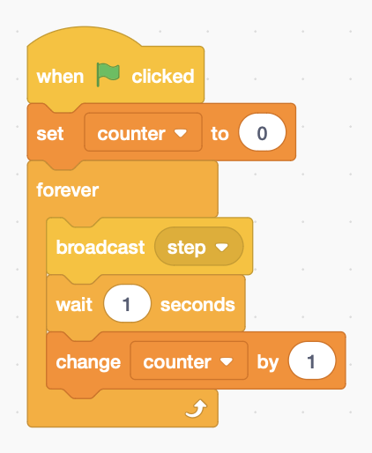To make all the invaders dance together, they need a clock to keep them in time.*

1. Add code to the **stage** that beats out the **steps**, and keeps count (make a **counter** variable, available to all).

*Look at the costumes and choose a pair of the same colour starting at 1, 3 or 5.*

1. 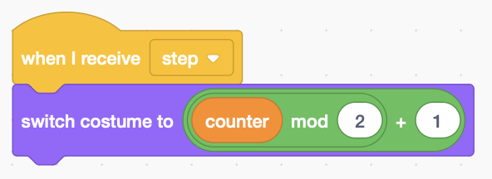Add code to the Invader sprite to **switch costumes** based on the counter. **Counter mod 2** is 0 or 1 for even and odd counts (the remainder after dividing by 2). Add this to your chosen costume number (1, 3, or 5).
2. Add code to make it **move**.

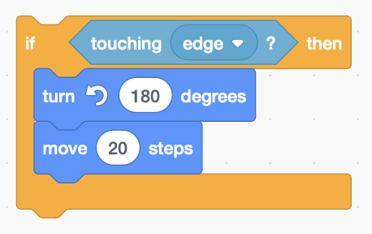*If your invader walks off-screen, get it back by changing x (in the sprite controls) to zero.*

1. Add code to detect the **edge** and **turn** the invader around 180°, and set the invader Direction to *reflect*.
2. 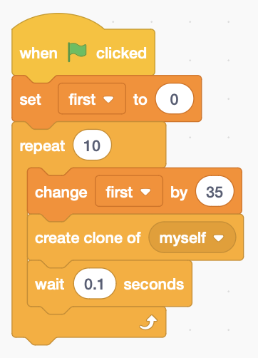Instead of making ten new sprites, **clone** the one you have. Create a variable **first** to position invaders on this first row (you can add more).

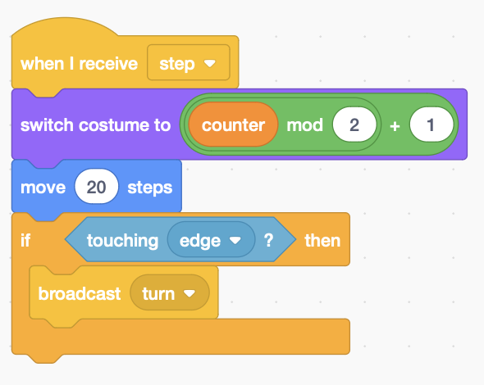*Place your invader to the left of the screen and try it! See how they pile up at the edge – now make them all turn at once.*

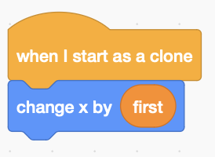

1. Change the code in the **if** to **broadcast** a turn instruction instead.
2. 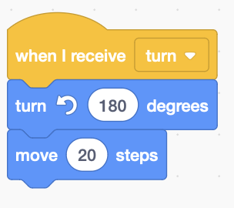Add code to **receive** the turn instruction

*Try adding another row (change* ***first*** *to* ***second****, or* ***third*** *row)*

*Remember to* ***Save*** *your code.*