# Scratch logo and symbol, meaning, history, PNG

**Jumping Beans**

*Make a sprite jump.*

Register/login at <https://scratch.mit.edu>

1. Make a new ‘**bean’** sprite with the drawing tool.
2. Make it smaller by adjusting its **Size**.
3. 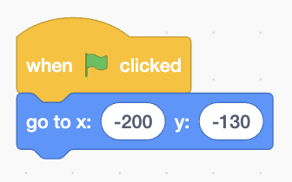Drag the bean to a starting point at the bottom lefthand corner. Add code that moves it to this position when you click the **green flag**.
4. 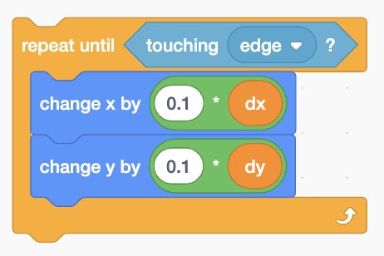Create two variables **dx** and **dy** and turn them into **sliders**. These are *differences* to be added to **x** and **y**.
5. Add code to **change** x and y **repeatedly** until it **touches the edge**. The values of **dx** & **dy** have to be scaled down using multiply.

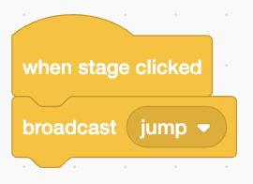*Try it. Click on the code to run it with* ***dx*** *&* ***dy*** *inputs.  
How do you sense a click on the background?*

1. 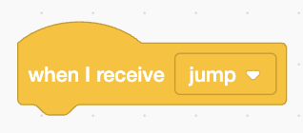Select the stage and add code that broadcasts a message when it’s clicked.
2. Add code to the bean that runs when it gets the message.

*Press the* ***flag*** *and click on the background*

*It moves in a straight line. Now add gravity!*

1. Add gravity by subtracting a small value from **dy** *every time it goes round the loop*.

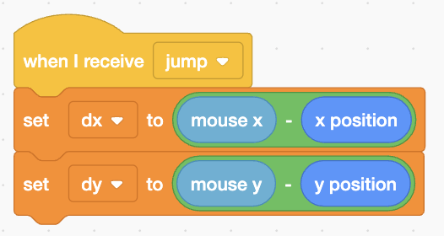*Use the mouse position to input the direction and speed of the jump, instead of the sliders.*

1. Insert code after the **receive message** to **set** **dx** and **dy** to the position of the mouse relative to the bean.
2. Make the bean tumble in mid-air by **turning** it 1 degree each time it moves.

*Add a target for the bean to hit.*

1. 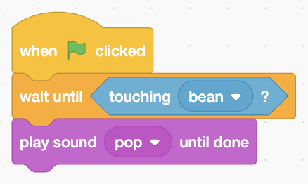Choose a new sprite with a good sound effect.
2. 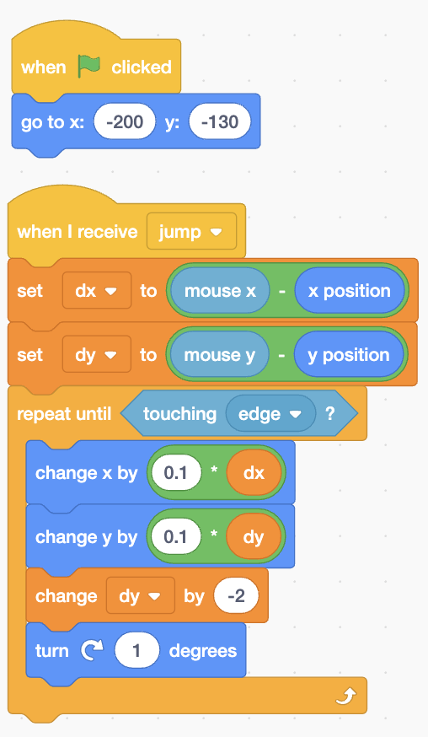Add code to the new sprite that **waits** until it **touches** the bean and then **plays** a sound.

*The complete code for the bean is shown here.*

*Can you improve the gameplay?*

***Save*** *your code with a good name.* ***File > Save now***