# Scratch logo and symbol, meaning, history, PNG

**Lip sync**

Register/login at <https://scratch.mit.edu>

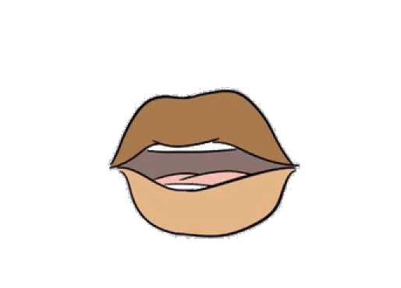*Make a character’s lips move in sync with your voice.*

1. Download graphics from: <https://codeclub67.github.io/images/lips.gif>
2. Create a new sprite from lips.gif

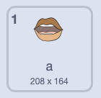*Look at the sprite’s* ***Costumes****. There are 26 (+1 extra) mouth shapes, one for each letter of the alphabet.*

1. Give each costume a new name, starting at “a” through to “z”.
2. There’s one extra costume, call this “**rest**” for when it’s not speaking.
3. Record a phrase on the **Sounds** tab. I recorded   
   “*The quick brown fox jumps over the lazy dog*”   
   (which uses every letter of the alphabet).

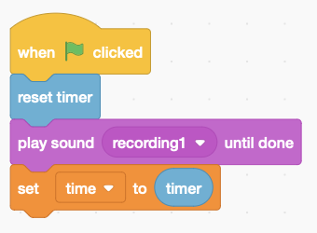 *How long is your sound?*

1. Create a variable, **time**, for the sound length.
2. Add the code to the right, using a **timer** to time the sound.

*Click on the green flag to time your sound*

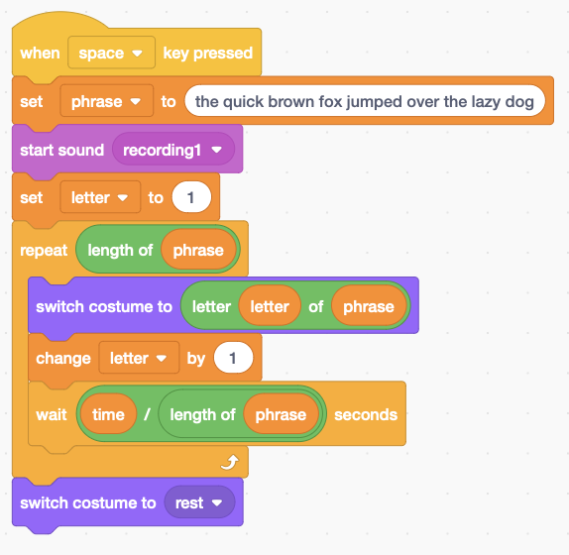*To lip-sync, step through the text of the phrase letter by letter, choosing the matching costume for each letter.*

1. Create variables for the text **phrase**, and for the **letter** counter.
2. Add the code to the right. Set up your phrase using only small letters (no capitals). **Start the sound** and lip-syncing by **switching costume** in a loop. “**letter … of**” pulls out a single letter from the phrase, at the **letter** position. It **waits** between each letter for the total **time** divided by the **length of** the phrase.
3. The sound and lip-sync should stop at the same time, so finish by **switching costume** to **rest**.

*Note that spaces in the phrase are just ignored because there’s no matching costume.*

*Use your artistic skills to add a face.*

***Save*** *your code with a good name.* ***File > Save now***

*The lip graphics remix a work by Jaida Salmon https://vimeo.com/202873560*