# Scratch logo and symbol, meaning, history, PNG

**Lizard Tiles**

Register/login at <https://scratch.mit.edu>

*Stamp interlocking sprites on the screen,   
like tiling a wall, using nested loops.*

1. Graphical user interface

   Description automatically generated with medium confidenceIcon

   Description automatically generatedClick on **Add Extension** and add the **Pen** extension.
2. Download graphics from: <https://codeclub67.github.io/images/lizard104.gif>
3. Create a new sprite with lizard104.

*The tile is like a jigsaw piece. The sides can interlock with each other.*

1. 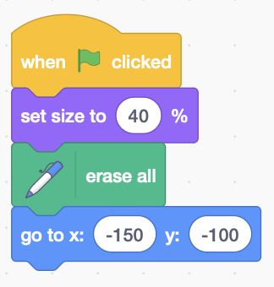Drag the sprite to the bottom-left of the screen and make a note of its x, y coordinates. Add code to clear the screen and initialise the size and position of the tile. When you add the **goto** block it uses these coordinates.
2. 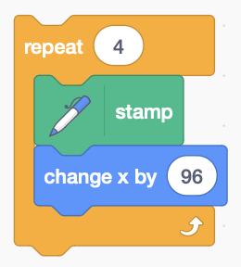Make a *row* of tiles from left to right, by **repeatedly** **stamping** the tile and **changing** **x** by the tile width.

*How do we tile upwards, as well as left to right?*

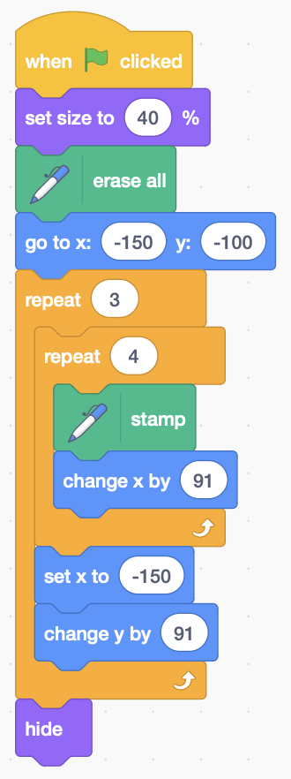*You can extend the tiles upwards by adding an outer loop that repeats the rows.*

1. With the outer loop added, the code now looks like this. The loop to stamp rows of tiles is *nested* within another loop.
2. After each row (inner loop) we **set x** back to the starting position, and **change y** by the height of the tile, so everything is ready to tile the next row.
3. 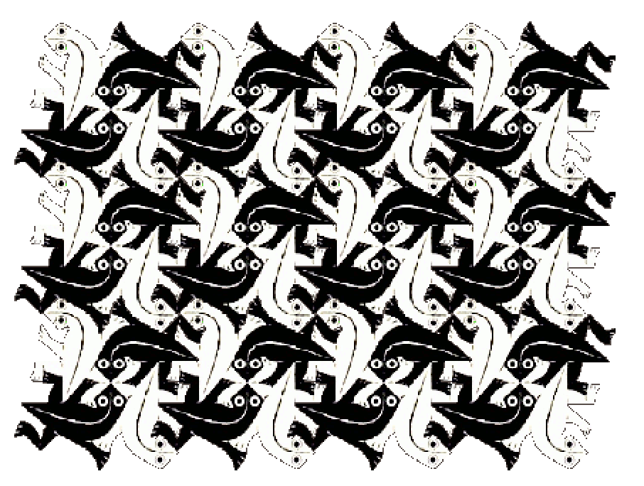Hide the sprite at the end so you can see what it stamped.

*Nested loops are really useful for working with things arranged in a grid, like these tiles.*

*This example is based on* ***Lizard (№ 104)*** *by M.C. Escher.*

*Remember to* ***Save*** *your code with a good name.****File > Save now***