# Scratch logo and symbol, meaning, history, PNG

**Robot follows orders**

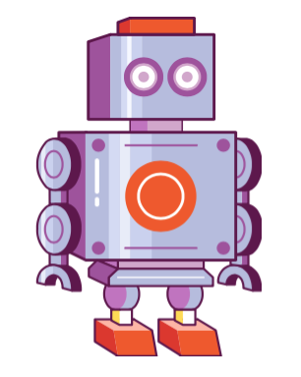

Register/login at <https://scratch.mit.edu>

Remember to write down your password.

*Order the robot to move up, down, left, right using x and y coordinates.*

1) Create a New Project

2) Select a Sprite and Choose a robot costume

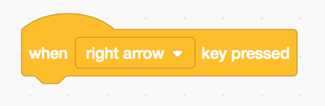

3) Add an event block,   
**when … key pressed**.   
Select **right arrow** to move right.

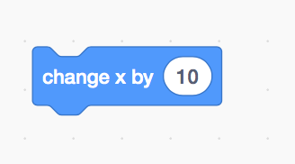

4) Choose a motion, **change x**, and add it to the block above.

***Try pressing the right arrow***

*Horizontal position is the* ***x axis****,*

***change x*** *to move horizontally.*

5) Add another event block,   
**when … key pressed**.   
Select **left arrow** to move left.

6) Add a **change x** block and change the number to **-10**.

**Try pressing the left arrow.**

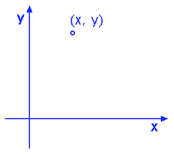*Increasing x moves the robot right,   
decreasing it makes it move left.*

*Can the robot move up and down?*

*Vertical position is the* ***y axis****. Move the robot up and down by changing y.*

7) Add another **When … key pressed** event and select **up arrow**.

8) Add **change y by 10.**

9) Finally, we can move down by subtracting 10.

*Where is the* ***origin****, position 0,0?  
You can drag the sprite about and check its x,y coordinates to find it.*

***Save*** *your code with a good name.* ***File > Save now***