# Scratch logo and symbol, meaning, history, PNG

**Orbital**

Register/login at <https://scratch.mit.edu>

*Make a planet with an orbiting moon.*

1. Create a sprite by choosing the “Earth.”
2. Create another new sprite, choosing “Planet2.”
3. Move **both** sprites to the **origin** (0,0) in the middle of the screen by setting their x, y coordinates to 0,0.

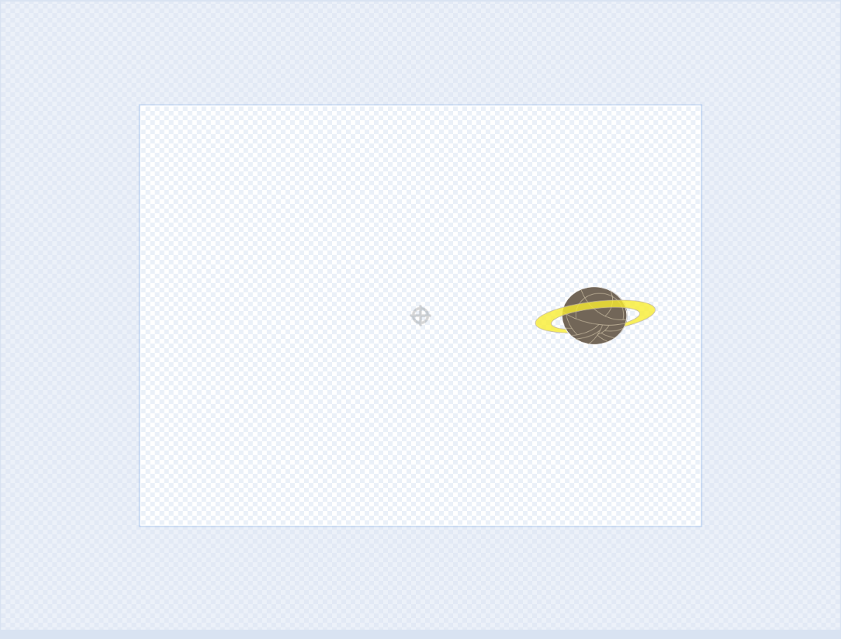*We can rotate a sprite around its centre. Normally the centre is in the middle of the graphic, but we can move it further out.*

1. Select the **Planet2** costumes tab and zoom out until you see the whole of the sprite editable area.
2. Use the selection arrow to select the whole Planet and its rings.
3. Drag the sprite to the right.

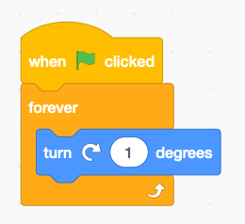*The centre of the sprite is shown as a small circle with a cross in it. That’s the point it rotates around.*

1. Add code (see right) to **Planet2** to slowly rotate it, turning 1° (degree) at a time.

*Press the* ***green flag****. It should orbit the Earth.*

*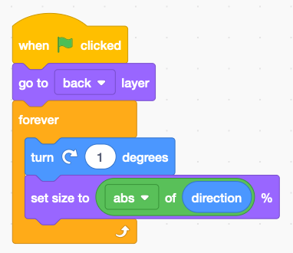Make it more exciting by changing the size, adding perspective. Make it look as though it’s passing behind the Earth, by putting it on the back layer.*

1. Edit the code (see right) to set the **size** to the angle (direction) so it changes size as it moves around its orbit.
2. Add a space backdrop to make it more realistic.

*Launch a rocket from Earth using the same trick.*

1. Create a new “Rocketship” sprite.
2. Move the Rocketship to the origin 0,0.
3. 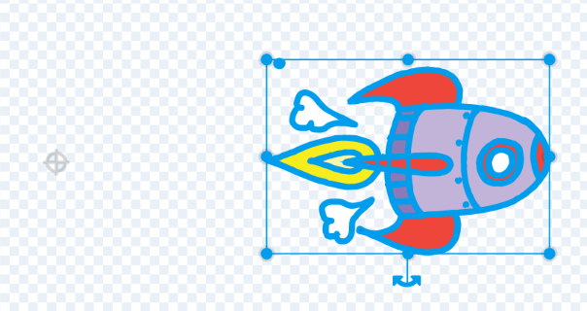Select the costumes tab and zoom out to the edge.
4. Select and drag the rocket to the right and this time rotate the graphic using the rotation ‘handle’ below it to make it point right.
5. 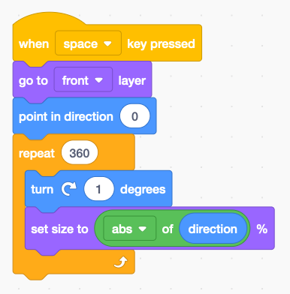Add code (right) to the **rocketship** to launch it when you press ‘space’ – geddit? **Turning** it 360° makes it turn a complete circle and return to Earth.

***Save*** *your code with a good name.****File > Save now***