# Scratch logo and symbol, meaning, history, PNG

**Super Scratch Racer**

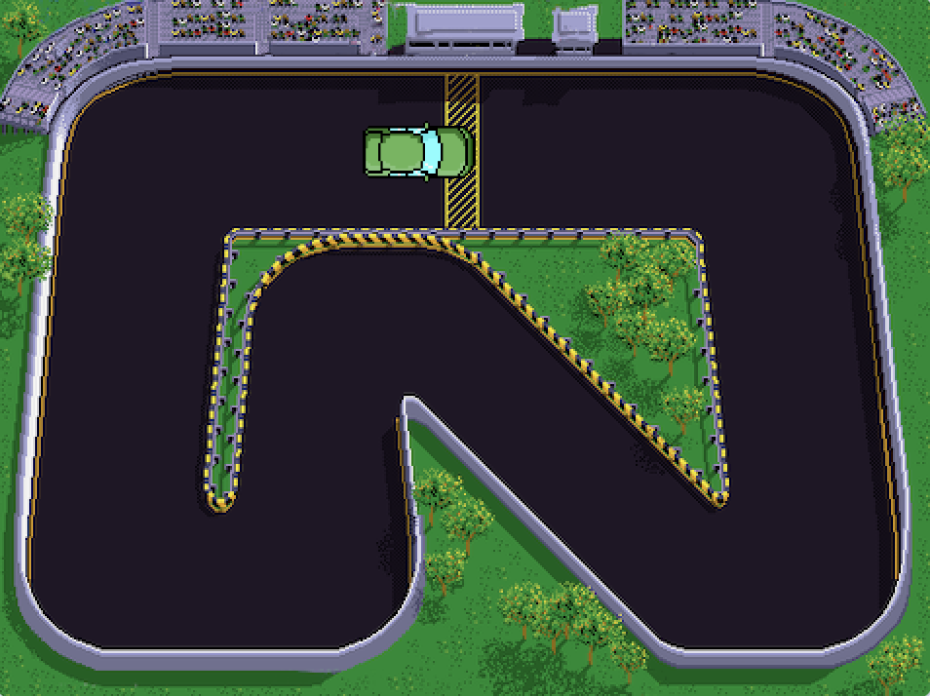

Register/login at <https://scratch.mit.edu>

*Steer the car round the track.*

1. Download the track image from:  
   <https://codeclub67.github.io/images/track.png>
2. Chart

   Description automatically generated with medium confidenceTo make the track, **Upload Backdrop** to the stage.
3. Download a car from:   
   <https://codeclub67.github.io/images/car.gif>
4. Create and **Upload Sprite** for the car
5. Graphical user interface, text, application, chat or text message

   Description automatically generatedChoose the car costume, and resize to **40%**.
6. The code starts by placing the car on the start line and pointing it in the right direction.

*Press the* ***green flag*** *to see the effect.*

1. Graphical user interface, text, application, chat or text message

   Description automatically generatedDrag the car to the first turn,   
   look at the car’s x, y position.
2. Add **glide to x,y** to the code.  
   Notice that x,y are already set to the car’s position.
3. A picture containing text, clock

   Description automatically generatedTurn the car by adding another **point in direction**.   
   Click on the angle and dial in the new direction so it’s facing the right way for the next section of track.

*Wave the* ***green flag*** *to start the race.*

1. Drag the car to the next turn and add another pair of **glide** and **point**.

*Run the race each time to see the effect.*

1. A picture containing shape

   Description automatically generatedContinue until the car has completed one lap, stopping on the start line.
2. Add a **loop** around the code to make the car drive round the track forever.

*Try adding another car by duplicating the first one, waiting for 1 second at the start to keep them apart.*

***Save*** *your code with a good name.* ***File > Save now***