# Scratch logo and symbol, meaning, history, PNG

**Scratchling**

Register/login at <https://scratch.mit.edu>

*Grow your own Scratch sapling – a scratchling.*

1. Graphical user interface

   Description automatically generated with medium confidence*Icon

   Description automatically generated*Click on the **Add Extension** button, and add the **Pen** extension.
2. Create a sprite using the **Tree1** graphic.
3. 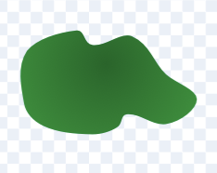In costumes, select one leaf and drag it to one side.
4. Delete the rest of the tree, then drag the leaf to the centre cross.

*Make a sapling (a young tree).*

1. 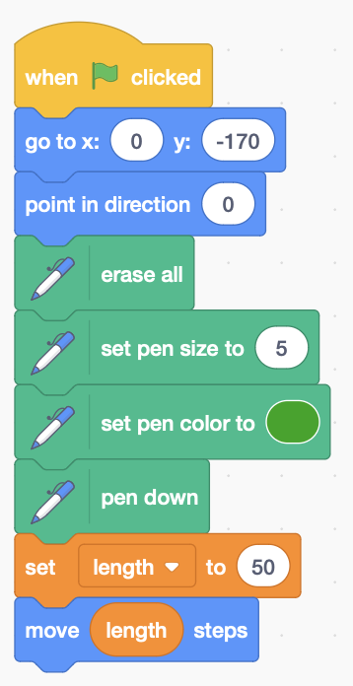Make a variable, for the **length of the stalk**, **for this sprite only**.
2. Add the code to the right. First, place the sprite somewhere near the bottom of the screen, **pointing** upwards.
3. Use pen commands to **erase** the screen, set the pen **size** and **colour**, and put the **pen down** to start drawing.
4. Initialise the stalk **length** to 50, and then **move** it to draw the stalk.

*Run this to see your new sapling*.

**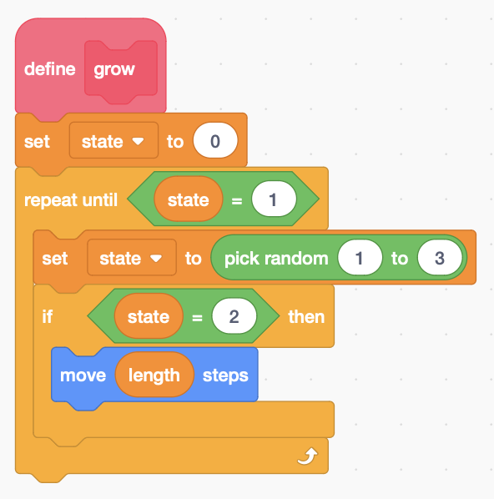***Grow your plant with a repeat loop*

1. **Make a block** to **grow** your plant.
2. Make a variable for the **state** of the plant, **for this sprite only**, and initialise it to zero.
3. **Randomise** the **state** each time round the loop, between 1 and 3.
4. When **state = 1** it exits the loop and stops growing.
5. **If** **state = 2** **move** the sprite to grow a little bit.
6. 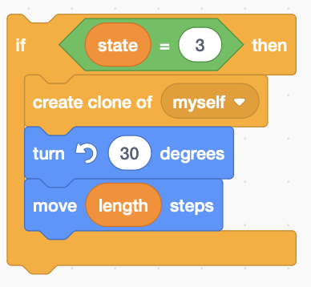Add to the end of your **green flag** code.

*Now the clever bit – the plant branches.*

1. Add code after the last **if**, inside the loop, so the main plant **turns** 30° left and a **clone** of the sprite branches right.
2. 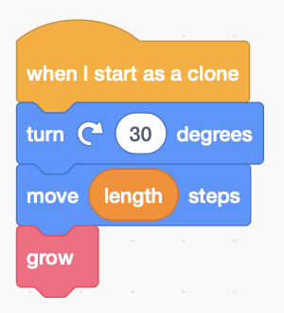Add code **when it starts as a clone** to **turn** 30° right, and continues to

*Is your plant a bit bushy? Prune it by cutting back the length each time round the loop.*

1. Add code at the end of the loop – but inside it – to scale back the **length** and reduce the pen **size**.

*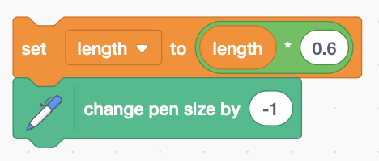Remember to* ***Save*** *your code with a good name.*