# Scratch logo and symbol, meaning, history, PNG

**Scratch Goes Shopping**

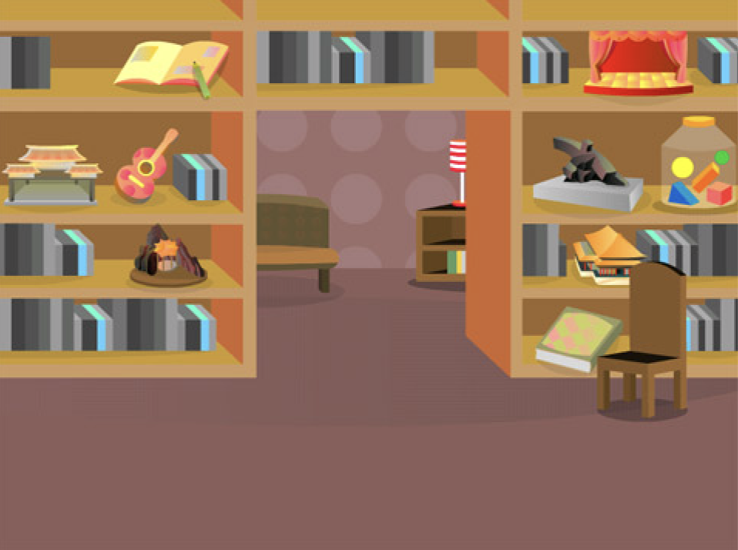Register/login at <https://scratch.mit.edu>

*Create a shopping trolley with a* ***List****.*

1. A cake with candles on it

   Description automatically generated with medium confidenceKeep Scratch the cat and look for a backdrop that will make a good shop.
2. 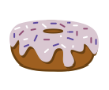A picture containing clipart

   Description automatically generatedIn **Variables**, **Make a List** for the shopping trolley, called **trolley**.
3. Find some items to sell in your shop.
4. *Chart

   Description automatically generated*Resize each item and put them somewhere on the shelves your shop.

*When you click on an item the price is added to the shopping trolley.*

1. *Graphical user interface, text, application, chat or text message

   Description automatically generated*Add this code to each item, to **add its price to the trolley** (change ‘1’ to a different price for each item).

*Click on items to add them to the trolley.*

1. Add code to Scratch to **delete all of the trolley** when the space key is pressed.

*Try adding and deleting items.*

*Now add up the prices in the trolley.*

1. Add the adding up code to Scratch the cat, which runs **when the green flag is clicked**.
2. Graphical user interface, application

   Description automatically generated**Make a Variable** to keep the **total**,   
   and clear it by adding **set total to 0**.
3. A close up of a cell phone

   Description automatically generated with low confidence**Make a Variable** called **n** to remember where you are in the list and **set n to 1**, the 1st item to be added.
4. Graphical user interface, application

   Description automatically generatedAdd a loop that **repeats** for each item in the trolley. The **length of trolley** is the number of times it loops around.

*******Add the following blocks* ***inside*** *the loop:*

1. *Graphical user interface

   Description automatically generated*Add the **nth item in the trolley** to the total
2. **Change n by 1,**for the next item.

*Add items to the trolley and add them up by   
clicking on the* ***green flag****.*

***Save*** *your code with a good name.* ***File > Save now***