# Scratch logo and symbol, meaning, history, PNG

**Snowflake**

Register/login at <https://scratch.mit.edu>

*Learn to make code blocks.

1. 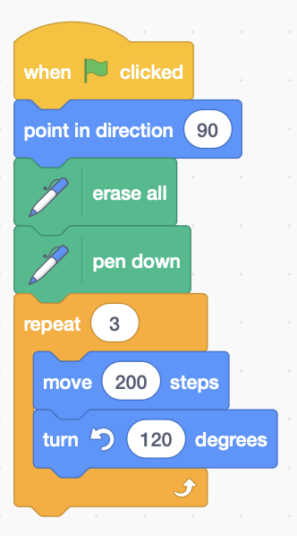Click on the **Add Extension** button, and add the **Pen** extension.

*First draw a triangle.   
Draw 3 sides, turning 120° each time.*

1. Add the triangle code shown here:

*Now* ***make a block*** *to draw each side.*

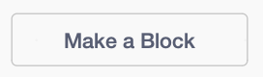

1. Under **My Blocks** click
2. 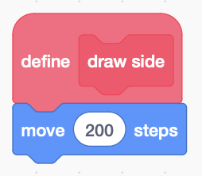Type in the block name “**draw side**” then **OK**.
3. A block appears which where you **define** what it does. For now, make it move 200 steps:

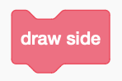

*A new block appears under* ***My Blocks***.

1. 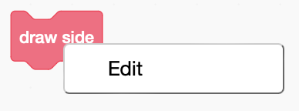Replace the **move 200** steps in your **green flag** code with the new **draw side** block.

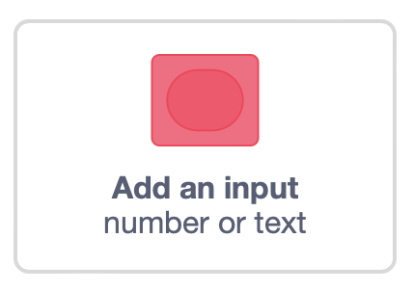*Your code blocks can have inputs.   
Add an input for the* ***length*** *of the side.*

1. **Right-click** then **Edit** your block under **My Blocks**.
2. 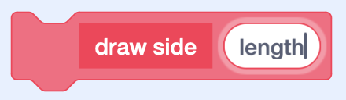Click **Add an input** (number or text).
3. Add the input name, “**length**”. **OK**
4. 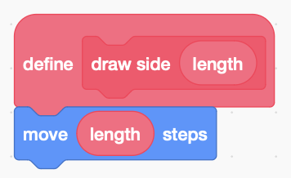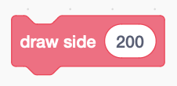A new slot appears for the input wherever you used the block. Add an input value, **200**.
5. Inside the block **definition**, *drag* the **length** input into the **move** block.

*60°*

*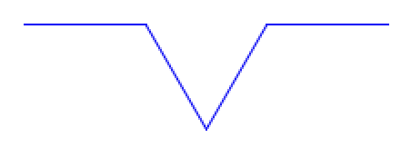Check your code still works… Now add a triangular out-dent on each side.*

*120°*

*60°*

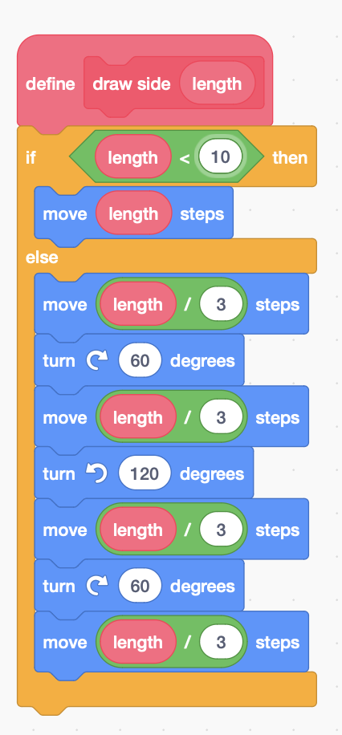

1. If the length is too small (less than 10) it does a basic move, otherwise it adds the out-dent with 4 moves, and 3 turns.

*The length of each of the four shorter line segments is* ***length******divided by******3****, or length* ***/*** *3.*

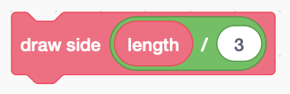*What will happen if you replace the four* ***moves*** *(in the else) with*    
?

*Try it. Here’s the complete definition.*

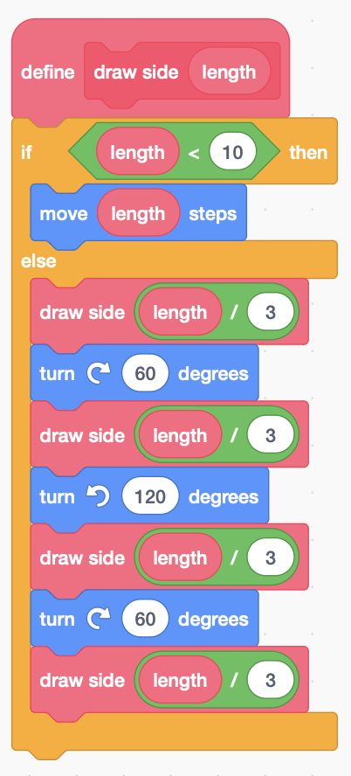

*Remember to* ***Save*** *your code with a good name.*