# Scratch logo and symbol, meaning, history, PNG

**Spooky Sounds**

Register/login at <https://scratch.mit.edu>

Keep your password safe.

*Make* ***sounds*** *in Scratch when you click on a sprite.*

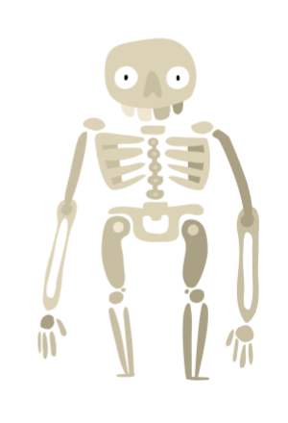

1. **Create** anew Project.
2. In the **Sprite** section, **choose a sprite**. Look in Fantasy characters and add Skeleton and Ghost.
3. Add a spooky fantasy backdrop.
4. Graphical user interface, application

   Description automatically generatedSelect the Skeleton. Open the **Sounds** tab. Skeleton has a rattle sound you can play.
5. Add a block to **start a sound when this sprite clicked**.

*Try clicking on the Skeleton.*

*What sound does a ghost make?*

*Make a recording.*

1. Select the Ghost and open the **Sounds** tab.
2. Graphical user interface, application

   Description automatically generated**Record** your ghost sound. You can add a name to your recording.
3. Add code to **start sound** **when this sprite is clicked**, and select your recording.
4. Graphical user interface, application

   Description automatically generatedChange the pitch of the sound to make it sound even more spooky. **Set pitch** to a positive number to speed it up, or a negative number to slow it down.

*Are there other spooky characters you can add?*

***Save*** *your code with a good name.****File > Save now***