# Scratch logo and symbol, meaning, history, PNG

**Squiral**

Register/login at <https://scratch.mit.edu>

*A* ***squiral*** *is a square spiral,   
not to be confused with a squirrel.*

1. Graphical user interface

   Description automatically generated with medium confidenceClick on the **Add Extension** button at the bottom left of the screen.
2. Select the **Pen** extension. New **Pen** code blocks appear below the other code blocks.
3. 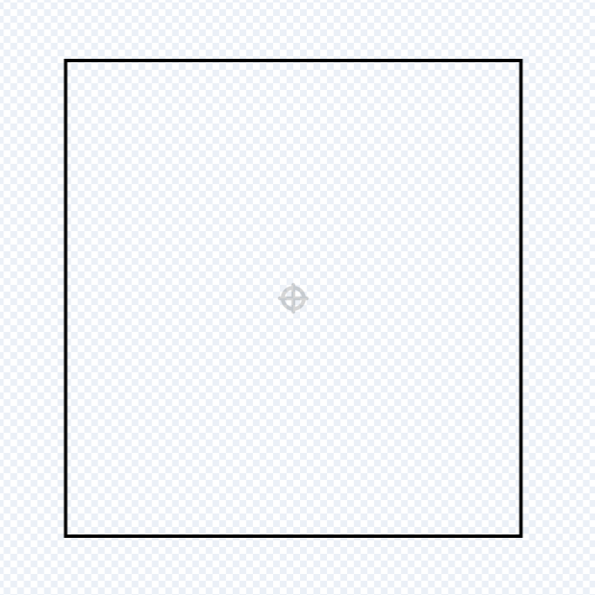Create a new sprite using the **Paint** tool.
4. Make a square with a solid outline but no fill colour.
5. 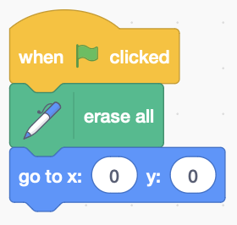Centre the square on the sprite.   
   Use the select arrow if you need to select a square you’ve already drawn.
6. When the **green flag** is clicked, use **erase all** to clear the screen.
7. Centre the sprite on the screen with **goto** 0,0

*Repeatedly rotate the square a small number of degrees.*

1. 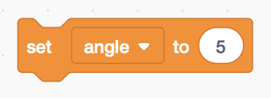Create a variable for the **angle**, and add code to set it to a small number, like 5° (degrees).

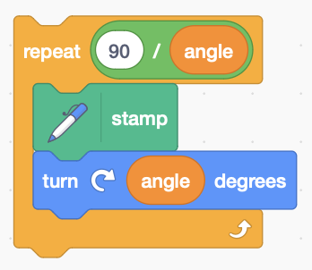*You only need to rotate a square 90° before it looks like the same square again.*

1. 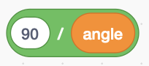**Repeat** the squaretimes.
2. 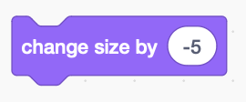Inside the loop, **stamp** the square and **turn** it through **angle** degrees.
3. 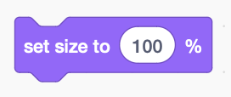Make the square a bit smaller each time. Reduce the size by changing it by a small **negative** number *inside the loop*.
4. Reset the size to 100% at the start.

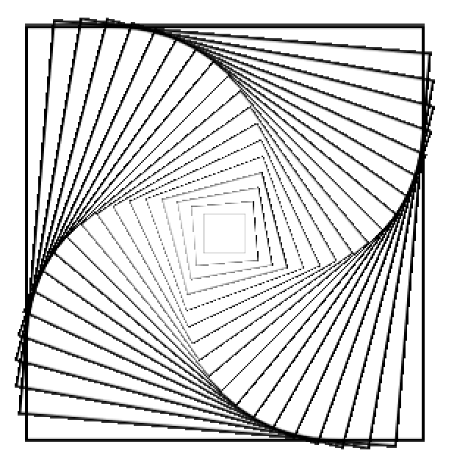

*Add colour. Fill the costume with* ***red****.*

1. Go through the colours of the rainbow by changing the colour inside the loop with a **change colour effect**

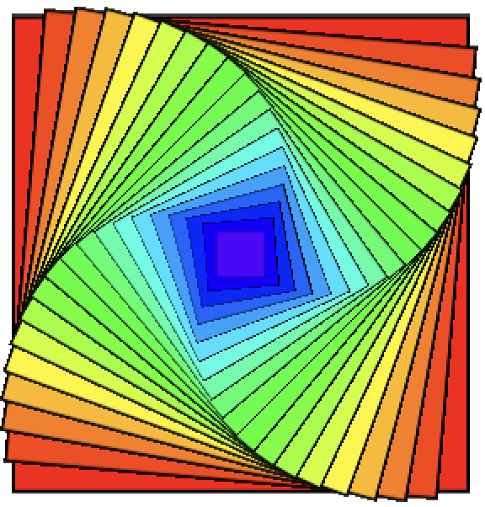

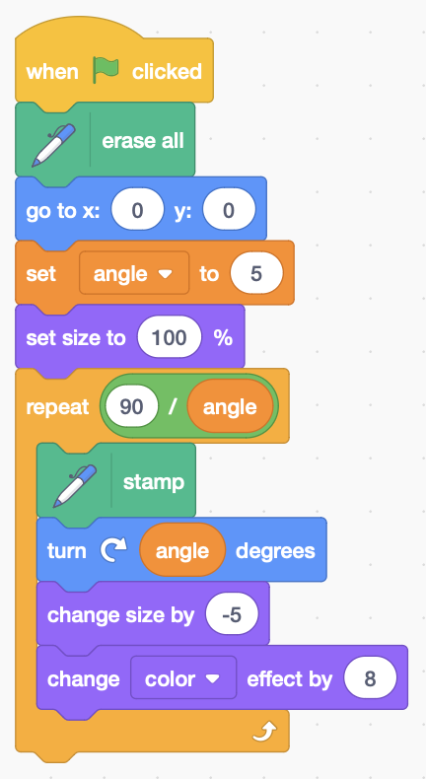*Choose the colour change so that you see all the colours of the rainbow:*   
red, orange, yellow, green, blue, indigo, violet.

*Remember to* ***Save*** *your code with a good name.****File > Save now***

*Here’s the complete code:*