# Scratch logo and symbol, meaning, history, PNG

**Scratch Story**

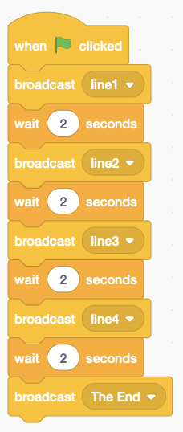Login at <https://scratch.mit.edu>

*Make up a simple 3 or 4 line story, or use a nursery rhyme like “Humpty Dumpty.” (https://en.wikipedia.org/wiki/Nursery_rhyme*).

* Create a “**story**” sprite to tell your story. Humpty Dumpty has four lines, starting with “*Humpty Dumpty sat on a wall.*”
* Add each line of the story as a separate sprite costume, using the “**T**” Text tool, and move them to the centre.
* There’s a bug that cuts off the text in the output. Fix it by converting them to bitmaps.

**Stage Code**

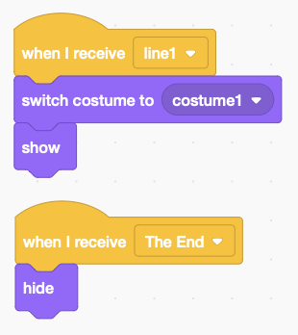*The stage drives the story, broadcasting a message for each line, waiting in between.*

* Add code to the stage (above right) with as many lines as you have in your story.
* Add code to your story sprite (right) to receive the messages and **switch** costume. Show and hide the sprite at the beginning and end of the story. **Try it!**

**Story sprite code**

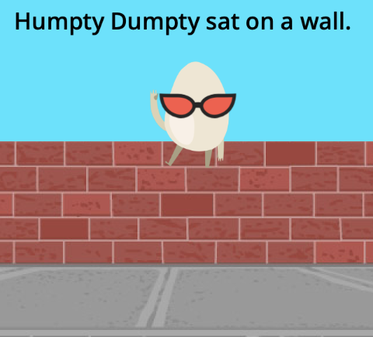*Add backdrops and characters to your story. I added a wall and a “Humpty Dumpty” egg.*

* Find or draw a stage backdrop, and drag your character to where it should appear.
* 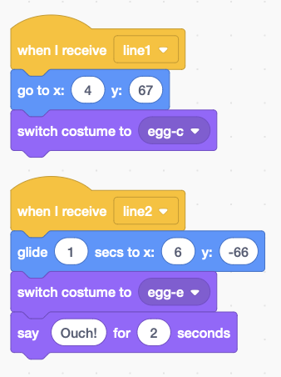Add code to your sprite to receive events and perform actions.
* **Position** it with **go to**, set to the position you dragged it to. *Humpty sits on the wall*.
* **Move** your sprite, by dragging it to a new position and add **glide**. *Humpty falls down*.
* Add **speech bubbles** with **say**.

*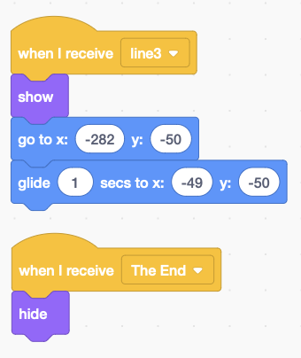****Show*** *and* ***hide*** *characters when they appear or disappear in your story.*

**Sprite movement**

* 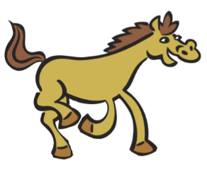For example (code right),   
  “*All the king’s horses*” appear in line 3, and disappear at the end.
* *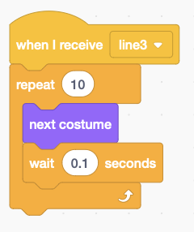***Animate** sprites by changing costumes quickly. You can animate galloping “king’s horses” for 1 second with the code below, right. **This can be done at the same time as it moves**.

**Show/hide sprite**

*Try switching to new backdrops on your stage.* ***Save*** *your code with a good name.* ***File > Save now***

**animate sprite**