# **Scratch logo and symbol, meaning, history, PNGn’ Swerve**

Register/login at <https://scratch.mit.edu>

*A car racing game using the mouse.*

1. Create a new Scratch project.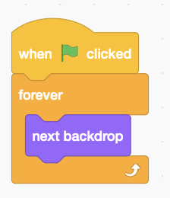
2. Download road highway graphics from: https://codeclub67.github.io/images/highway.gif
3. Upload **highway.gif** to the stage and delete backdrop 1 which is blank.
4. Add stage code (right) to cycle through the images.

stage code

1. 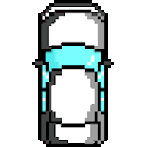 Download car graphics from:  
   https://codeclub67.github.io/images/microcar.gif
2. Create a new sprite from **microcar.gif**, set size to 35% and drag it near to the bottom of the screen.
3. A screenshot of a computer

   AI-generated content may be incorrect.Add code to the white microcar to steer it left and right when you move the mouse.

***mousex*** *is the horizontal, or x position of the mouse.*

*The vertical, or y position of the car is fixed near the bottom of the screen   
(-130).*

White car code

*Red, green, and blue cars* ***glide*** *down from the top of the screen, as though you’re overtaking them*

microcar code

1. 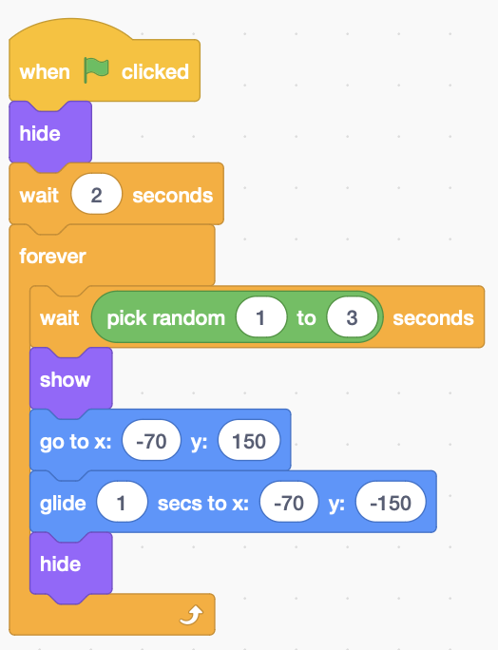Duplicate the white car, choose the red car **costume**, and rename the sprite as “red car”.
2. Delete any existing code from the red car and add code (right).   
   *Use a horizontal position (x value) of****-70*** *for the red car. The middle lane has an* ***x value*** *of 0. Use* ***-70*** *and* ***70*** *for the left and right-hand lanes.*
3. Duplicate the red car to make green and blue cars.

red car code (x = -70)

1. Change x values of the green car to **0** for the middle lane, and to **70** for the blue car in the right-hand lane.
2. Add code to the white car loop to detect car crashes.A screenshot of a computer

   AI-generated content may be incorrect.

White car code

***Save*** *your code with a good name.****File > Save now***