# Scratch logo and symbol, meaning, history, PNG

**Tessellation**

This week we will use: <https://tiled.art>

*Tessellations are tiles you can put together like a jigsaw puzzle, but every piece is the same!*

1. 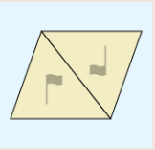Click **Create**
2. Tiles can be flipped over and rotated – these are its *symmetries*. Click the **2-way Triangles rotated** symmetry.
3. Draw some kind of animal.

* *You can bend the triangular outline by clicking on an edge to add a control point and then dragging it.*
* *A white cursor and a blue background

  AI-generated content may be incorrect.Switch between curved and sharp corners by selecting these from the menu:*
* *A blue and white sign with a fish and a letter c

  AI-generated content may be incorrect.You can add* ***eyes*** *to your animal by switching from editing the tile shape to editing tile detail (select the pen to draw).*

1. When your tile is finished you can save your work with the Save button:
2. To save your work in a Scratch-ready format, click on the second button down (a folder) …
3. Select “Export PNG image” and choose “Key tile only” in the **content** menu.
4. Click “Export”, choose a Title, then “Export” again.

Register/login at <https://scratch.mit.edu>

1. Create a new sprite with the PNG you just saved.
2. Change the colour using the fill tool on the costumes tab.
3. 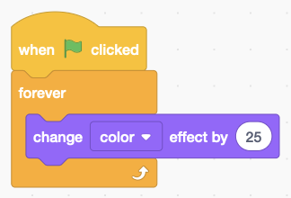Add code to change the colour of the sprite. The colour effect shifts the colour and can be any number between 0 and 199.
4. Create a **counter** variable **for this sprite only**.

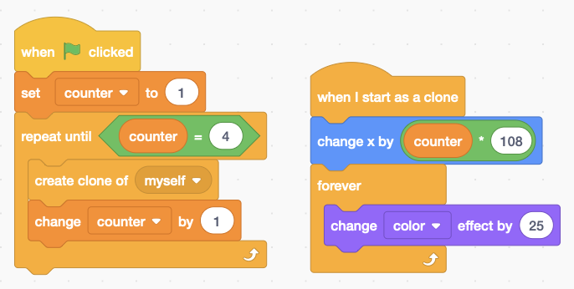*Make 4 copies of the tile by cloning it with different values of x.*

1. Add code (right) to clone a row of tiles.

*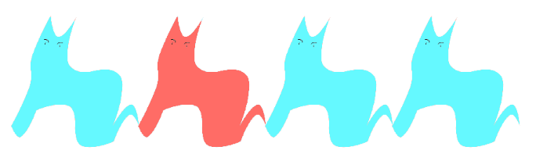The tricky thing is to find a change of* ***x*** *so the sprites touch without leaving a gap (108 works for me).*

1. 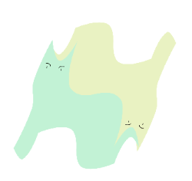Duplicate the sprite and turn it upside down, changing **Direction** from 90 to -90 degrees.
2. Fill this new tile with a different colour.

*Fit the pieces together like a jigsaw puzzle.*

***Save*** *your code with a good name.* ***File > Save now***