# Scratch logo and symbol, meaning, history, PNG

**Tessellation**

This week we will use: <https://tiled.art>

*Tessellations are tiles you can put together like a jigsaw puzzle, but every piece is the same!*

1. 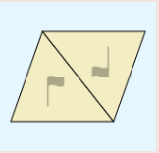Click **Create**
2. The tiles can be flipped over and rotated – these are its *symmetries*. Click the 2-way Triangles rotated symmetry.
3. Draw some kind of animal.

* *You can bend the triangular outline by clicking on an edge to add a control point and then dragging it.*
* *A white cursor and a blue background

  AI-generated content may be incorrect.Switch between curved and sharp corners by selecting these from the menu:*
* *A blue and white sign with a fish and a letter c

  AI-generated content may be incorrect.You can add* ***eyes*** *to your animal by switching from editing the tile shape to editing tile detail (select the pen to draw).*

1. When your tile is finished you can save your work with the Save button:
2. To save your work in a Scratch-ready format, click on the second button down (a folder)…
3. Select “Export PNG image”, and choose “Key tile only” in the **content** menu.
4. Click “Export”, choose a Title, then “Export” again.

Register/login at <https://scratch.mit.edu>

1. Create a new sprite with the PNG you just saved.
2. 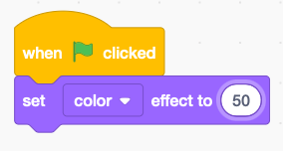Add code to change the colour of the sprite. The colour effect shifts the colour and can be any number between 0 and 199.

*The tile is like a jigsaw piece.*

1. Duplicate the sprite and turn it upside down by changing Direction from 90 to -90.
2. 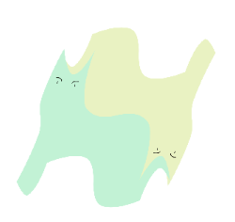Make this new tile a different colour by changing the colour effect to a different number.

*Drag the tiles around and fit them together like a jigsaw puzzle.*

1. 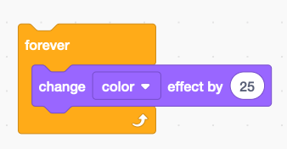Make the tiles change colours by adding a loop to change the colour effect:
2. Duplicate both tiles a few times and fit them together like a puzzle.

***Save*** *your code with a good name.****File > Save now***