# Scratch logo and symbol, meaning, history, PNG

**Tetris**

Register/login at <https://scratch.mit.edu>

*Assemble the blocks as they drop.*

1. Click on the **Add Extension** button at the bottom left of the screen, and select the **Pen** extension.
2. Download block images from:  
   <https://codeclub67.github.io/images/block.gif>

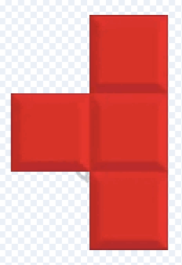

1. Create a new sprite by uploading the block images.
2. 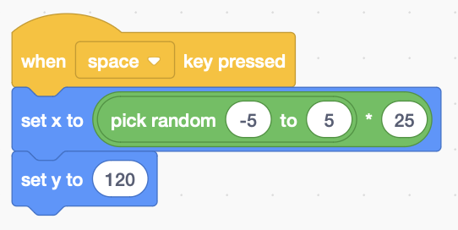**Convert each costume to a vector** and move it so the centre is exactly at a corner of a 50x50 square.
3. Change the sprite size to 50%.
4. 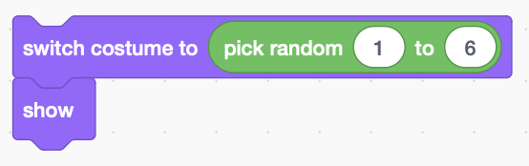**When the space key is pressed**, place the block randomly at the top of the screen (a multiple of 25, half 50x50).
5. 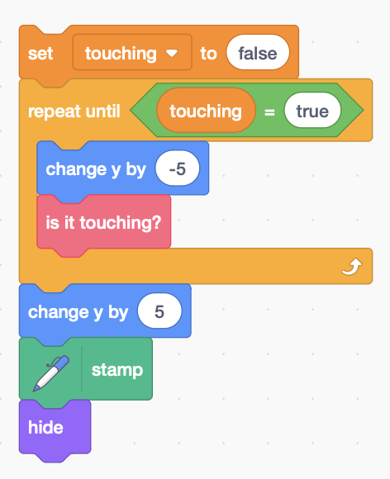Pick a costume at random, and show it.

*The block falls until it* ***touches*** *something.*

1. Make a variable called **touching**
2. Set **touching** to **false**, then **repeatedly** move the block down until it’s **true**.
3. **Make a block** called “**is it touching?**”
4. When the loop finishes, **stamp** the sprite slightly above its final position, then **hide** it.

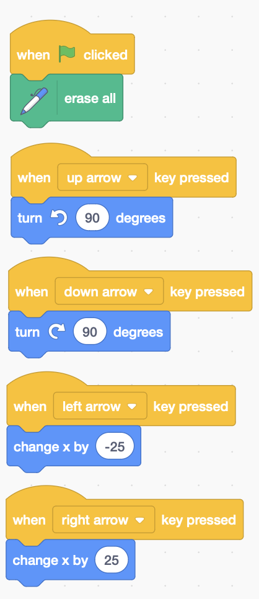

*The code above stamps a copy of the block where it falls.   
Now you need to control the fall.*

1. Add controls, so you can move the block left and right and rotate it. Use the **flag** to clear the screen.

*The new code block detects when it’s touching the edge,   
or touching another block.*

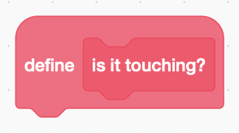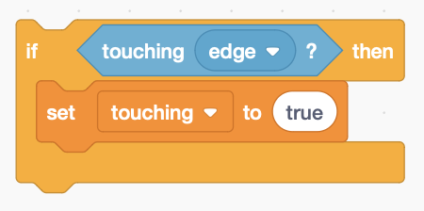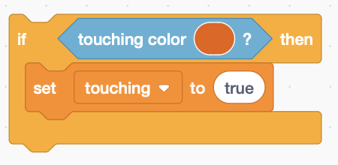

1. First, detect when the block touches the edge of the screen.
2. Add code to detect a block colours.
3. Drop a block then click on the colour swatch in **touching colour**.
4. Use the colour picker tool to select the block colour.
5. Duplicate the **touching colour** code above and drop more blocks, until you’ve picked out the colours of all six costume shapes.

*Remember to* ***Save*** *your code.*