# Scratch logo and symbol, meaning, history, PNG

**Haunted House**

Register/login at <https://scratch.mit.edu>

Remember to write down your password.

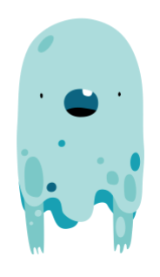

*What happens when sprites* ***touch*** *each other?*

1. **Create** anew Project and give it a name.
2. In the **Sprite** section, **choose a sprite**. Look for the ‘Fantasy’ **Ghost** character. Keep Scratch the Cat for now.
3. Look for a **background** for your haunted house.
4. Graphical user interface, application, chat or text message

   Description automatically generatedAdd code to make the Ghost ‘haunt’ the house. Click on its **Code** tab. Add a **start** block and a **forever** loop. Inside the loop make the Ghost **glide** around randomly.

1. Chart

   Description automatically generatedWe can make the Ghost sense when it’s **touching** another sprite.
2. Add a block to decide what to do **if** they touch.
3. ***Graphical user interface, application

   Description automatically generated***When they touch, **switch costume** (make it wave its arms?) and **say** “Booooh!”.
4. Graphical user interface

   Description automatically generatedThe **else** part is what to do if they are **not** touching. **Switch** back to the first Ghost costume.
5. Put this inside a **forever** loop that starts when you click on the **flag**.

*******To help Scratch the cat run away from the ghost we need to make him move.*

1. Add code to Scratch the cat that loops **forever**, and will **go to** the mouse pointer position.

*Remember to* ***Save*** *your code with a good name.* ***File > Save now***