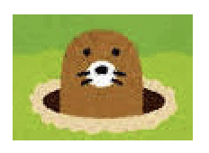

# **Scratch logo and symbol, meaning, history, PNGWhac-a-Mole**

**Whac-A-Mole** is a game where moles pop up at random. Points are scored by whacking each mole as it appears.

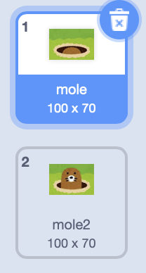

1. Download the mole image from:  
   https://codeclub67.github.io/images/mole.gif
2. Create a new sprite and choose **upload sprite** to get the downloaded mole image. Have a look at the costumes.

*This is an animated GIF so it includes costumes for the mole being both down & up.*

1. Graphical user interface, application

   Description automatically generatedKeep track of the number of moles you whack by adding a score. **Make a variable** (for all sprites) called **score**.
2. Clear the score at the start of the game.
3. Graphical user interface, application

   Description automatically generatedAdd a **forever** loop to the code above.
4. Inside the loop, the mole **waits** for a **random** time before popping up, and then pops down again after 1 second.
5. Graphical user interface, application

   Description automatically generatedTo tell when the mole is whacked, detect **when this sprite clicked**.
6. Only increase the score **if** the mole is up, when **costume number = 2**
7. Once the mole has been whacked, switch the costume back to the mole being down.

*You can* ***duplicate*** *the sprite as many times as you like, and put them side-by-side.*

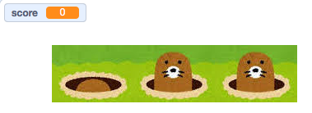

*What sound effects could you add?*

*Remember to* ***Save*** *your code with a good name.****File > Save now***