# Scratch logo and symbol, meaning, history, PNG

Register/login at <https://scratch.mit.edu>

(remember/write down your password here)

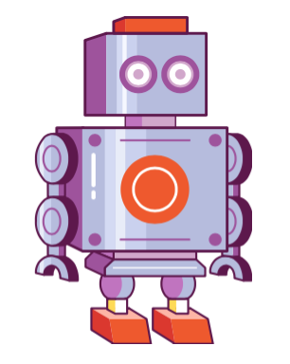1) +New Project

2) Select the Sprite - Choose a costume

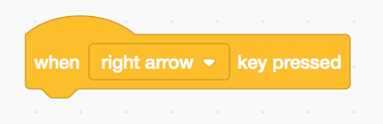

3) Choose an event “When ? key pressed”. Change to right arrow.

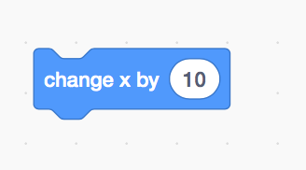

4) Choose a motion

5) Join them together

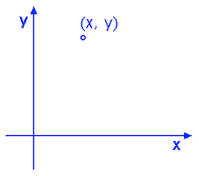6) Can you move the robot in different directions?

You can change x by negative amounts to move left

7) Or you can change the y direction to move up and down

8) Where is the origin, position 0,0?  
You can drag the sprite about to find it.